**ABTRACT**

The Project Named “ANALYTICS TOOL FOR PLACEMENT CELL” is a student/company web-based Information system. Training and Placement Cell is the management cell it is supported by databases. Training and Placement has a major role in every college in which most of the work till now is carried out manually. The Main aim of this project is to Automate the Training and Placement procedure in our college. This project reduces manual work and maximum the optimization, abstraction and security. This is a web application which will help students as well as the administration authority to carry out each and every activity in campus hiring. This system is an application that can be accessed throughout the organization and outside as well with proper login credentials. This system can be used as an application for the Training and placement cell of the college to manage the student information with regarding placement recruitment. Students able to view eligibility criteria based on their CGPA for the up-coming placement drives and they can access technical and QA papers regarding particular company.

***TABLE OF CONTENTS***

|  |  |  |
| --- | --- | --- |
| CHAPTER NO. | TOPIC | PAGE NO. |
|  | **ABSTRACT** | i |
|  | **LIST OF FIGURES** | **ii** |
|  | **LIST OF EXPANSIONS** | Iii |
| 1 | **INTRODUCTION** |  |
|  | 1.1 PROJECT OVERVIEW | 4 |
|  | 1.2 PURPOSE | 5 |
| 2 | **LITERATURE REVIEW** |  |
|  | 2.1 EXISTING PROBLEM | 6 |
|  | 2.2 REFERENCE | 8 |
|  | 2.3 PROBLEM STATEMENT DEFINITION | 10 |
| 3 | **IDEATION &PROPOSED SOLUTION** |  |
|  | 3.1 EMPATHY MAP CANVAS | 11 |
|  | 3.2 IDEATION &BRAINSTORMING | 11 |
| 4 | **REQUIREMENT ANALYSIS** |  |
|  | 4.1FUNCTIONAL REQUIREMENT | 14 |
|  | 4.2 NON FUNCTIONAL REQUIREMENT | 14 |
| 5 | **PROJECT DESIGN** |  |
|  | 5.1 DATA FLOW DIAGRAM & USER STORIES | 15 |
|  | 5.2 SOLUTION ARCHITECTURE | 16 |
| 6 | **PROJECT PLANNING &SCHEDULING** |  |
|  | 6.1 TECHNICAL ARCHITECTURE | 17 |
|  | 6.2 SPRINT PLANNING &ESTIMATION |  |
|  | 6.3 SPRINT DELIVERY SCHEDULING |  |
| 7 | **CODING & SOLUTION** |  |
|  | 7.1 FEATURE 1  7.2 FEATURE 2 | 20 |
| 8 | **PERFORMANCE TESTING** |  |
|  | 8.1 PERFORMANCE METRICS | 43 |
| 9 | **RESULTS** |  |
|  | 9.1 OUTPUT SCREENSHOTS | 45 |
| 10 | **ADVANTAGES AND DISADVANTAGES** |  |

**11**  **CONCLUSIONS**

**12 FUTURE SCOPE 52**

**13 APPENDIX**

**SOURCE CODE 53**

|  |  |  |
| --- | --- | --- |
| **S.NO** | **TITLE** | **PAGE NO** |
| **1** | **SYSTEM DIAGRAM** | **12** |
| **2** | **DATAFLOW DIAGRAM** | **15** |
| **3** | **SOLUTION ARCHITECTURE** | **16** |
| **4** | **TECHNICAL ARCHITECTURE** | **17** |
| **5** | **SPRINT PLANNING &ESTIMATION DIAGRAM** | **18** |
| **6** | **CODING** | **20** |
| **7** | **Representation For Placement by Secondary Education Boards and Higher Education Board** | **45** |
| **8** | **Representation For Placement By Gender and Work Experience** | **47** |
| **9** | **Representation For Placement By Specialization** | **48** |
| **10** | **Representation of Result Summary , actual and predicted values** | **49** |

**CHAPTER 1**

**INTRODUCTION**

Our project is mainly focused on analysis and tracking of student Performance in placement drives. To implement this application, coordinator has to collect the student’s data, those who are eligible and qualified for the aptitude and future rounds. The current system is computerized one, but it does not meet the needs of Training and Placement Cell. In existing system, the student’s data is maintained in Excel Sheets. According to the Company’s Requirement the data is short listed manually by the TPO's. Handling and maintaining of student’s data manually is hectic to the T&P Deptartment and sometimes it might be inaccurate. To overcome these limitations, we proposed new system called “AN EFFECT OF ERP ON WEB BASED PLACEMENT ANALYSIS AND TRACKING SYSTEM”.

The main purpose of this project is to add new features to existing system. The proposed one is an online system which can be accessed throughout the Organization and outside as well with valid login credentials. This system can be used as an application for the Training and Placement Department of the college to manage student’s information regarding Placements. The student’s record includes personal details, educational qualifications, professional skills and academics etc.,This system acts as central repository for student information.

**1.1 PROJECT OVERVIEW:**

This project is designed to help students for applying jobs. Placement management system mainly focused to interact the student and company. Students can create profiles on the system directly. They can edit their profiles and the student profiles can be viewed by the recruiters. It will help to apply for the job where they fit in. Students can only apply jobs when they match with the eligibility criteria. The IRP admin manages with the permissions of the department admin and the department admin manages all the things which are related to the students and recruiters.

**1.2 PURPOSE:**

 This project covers wide scope of information of all the students which can be stored in the format of CV’s are categorized according to various streams. Various companies can access the information of students and they can maintain and update their information. Notifications are sent to students about the companies.

Students can access previous information regarding.

• View Student Profile

• Company Page

• Company recruitment schedule Page

• View Recruitment Schedule

• View Selected List of Students

• Coordinator page includes ongoing page, process page

• Upload technical papers.

**CHAPTER 2**

**LITERATURE REVIEW**

**1.TITLE:** Almahdi Alshareef, Ahmed Alkilany "Toward a Student Information System for Sebha University, Libya",Fifth international conference on Innovative Computing Technology.

**INTRODUCTION:** AlmahdiAlshareef, Ahmed Alkilany basically focuses on providing a simple interface for the easy collation and maintenance of all manner of student information. The creation and management of accurate, up-to- date information regarding students’ academic careers is critical students and for the faculties and administration of Sebha University in Libya and for any other educational institution. A student information system deals with all kinds of data from enrollment to graduation, including program of study, attendance record, payment of fees and examination results to name but a few. All these data need to be made available through an Online Interface.

**2.TITLE:** Prabhu T Kannan, Srividya K Bansal,"Unimate: A Student Information System",2013 International Conference on Advances in Computing, Communications and Informatics.

**INTRODUCTION:** Prabhu T Kannan, Srividya K Bansal focuses on providing information to support the operation, management and decision-making functions of enterprises or organizations. In the face of huge amount of information, it is required to possess the student information management system to improve the efficiency of student management. Through this system, the standardized management, scientific statistics and fast query of student information can be realized, and thus the workload of management can be reduced. In this paper, a typical student information management system will be established to realize the systematization, standardization and automation of student information relationship.

**3.TITLE:** T. Jeevalatha, “Performance Analysis of Undergraduate Students Placement Selection using Decision Tree Algorithms”, Dept, ofComputer Science Dr. N.G.P Arts and Science College Coimbatore Tamil Nadu, India.

**INTRODUCTION:** S.R.Bharamagoudar, Geeta R.B, S.G.Totad focuses on simple interface for maintenance of student information. The creation and management of accurate, up-todate information regarding a student’s academic career is critically important in the university as well as colleges. Student information system deals with all kind of student details, academic related reports, college details, course details, curriculum, batch details, placement details and other resource related details too. It tracks all the details of a student which can be used for all reporting purpose, tracking of attendance, progress in the course, completed semesters, years. Different reports and Queries can be generated based on vast options related to students, batch, course, faculty, exams, semesters, certification and even for the entire college.

**2.1 EXISTING SYSTEM :**

The Existing system does all process has done by manually. Placement officers maintain the information about students manually. If any modifications or updates are required in their profile of any students, it has to be done manually. This is very difficult task for TPO to maintain the student data and company details as it is time consuming, lack of security of data and also it takes more man, etc,. This is so difficult to the Tpo when number of user's increases

**Existing systems and tools in placement analytics are::**

1. **Applicant Tracking Systems (ATS):** ATS software helps manage job applications and streamline the recruitment process. It allows recruiters to track candidates' progress, store resumes, and collaborate with team members.
2. **Job Boards**: Platforms like LinkedIn, Indeed, and Glassdoor provide analytics tools for employers to track the performance of job postings, view applicant demographics, and assess the effectiveness of their job advertising.
3. **Predictive Analytics Tools:** These tools use historical hiring data and machine learning algorithms to predict which candidates are most likely to succeed in a role. They can help companies make more informed hiring decisions.
4. **HR Analytics Platforms**: These tools provide comprehensive analytics on various HR metrics, including hiring, onboarding, and retention. They can help organizations identify trends and patterns in their hiring processes.
5. **Assessment and Testing Tools**: Tools like SHL, Hogan Assessments, and others offer assessments and tests to evaluate candidates' skills, personality traits, and cultural fit. Analytics within these tools help assess candidate suitability.
6. **Video Interview Platforms**: These platforms, such as HireVue and Spark Hire, provide video interviewing and analytics to evaluate candidate responses, body language, and other interview data.
7. **Resume Screening Software**: Resume parsing and screening tools like Taleo and Workday help organizations efficiently scan and analyze resumes to identify qualified candidates.
8. **Custom Analytics Dashboards**: Some organizations build custom analytics dashboards using business intelligence tools like Tableau, Power BI, or QlikView to analyze and visualize placement-related data specific to their needs.
9. **Performance Analytics Tools:** These tools, often integrated into HR software like Workday, offer analytics on employee performance and can help with identifying high-performing candidates for placement.

**2.2 REFERENCE :**

1. Vidhate, Deepak A and Kulkarni, Parag “Innovative Approach Towards Cooperation Models for Multi-agent Reinforcement Learning (CMMARL)”, Springer Nature series of Communications in Computer and Information Science, Vol. 628
2. Vidhate, Deepak A and Kulkarni, Parag “New Approach for Advanced Cooperative Learning Algorithms using RL Methods (ACLA)” Proceedings of the Third International Symposium on Computer Vision and the Internet, ACM, pp 12-20, 2016
3. T. Jeevalatha, “Performance Analysis of Undergraduate Students Placement Selection using Decision Tree Algorithms”, Dept, ofComputer Science Dr. N.G.P Arts and Science College Coimbatore Tamil Nadu, India.
4. Dr. Rajan Vohra, “Generating Placement Intelligence in Higher Education Using Data Mining”, Head of Dept. Computer Science & Engineering Dept P.D.M College Of Engineering, Bhadurgarh , Haryana(India).
5. Tejashri Gosavi, Shraddha Gaikwad, “Android Based Training and Placement Automation”, Department of Computer Engineering, JSPM’s ICOER , Wagholi , Pune , India
6. Vidhate, Deepak, A; Kulkarni, Parag (2014):“Improvement In Association Rule Mining By Multilevel Relationship algorithm” in International Journal of Research in Advent Technology, 2(1), pp.366-373 Vidhate, Deepak A and Kulkarni, Parag “Performance enhancement of cooperative learning algorithms by improved decision making for context based application”, International Conference on Automatic Control and Dynamic Optimization Techniques (ICACDOT)IEEE Xplorer, pp 246-252, 2016
7. Vidhate, Deepak A and Kulkarni, Parag “Single Agent Learning Algorithms for Decision making in Diagnostic Applications”, SSRG International Journal of Computer Science and Engineering (SSRG-IJCSE), Vol.3, No.5,pp.46-52,2016
8. Vidhate, Deepak A and Kulkarni, Parag “Enhancement in Decision Making with Improved Performance by Multiagent Learning Algorithms” IOSR Journal of Computer Engineering, Vol. 1,No. 18,pp 18-25,2016
9. G. Bonfante, M. Kaczmarek, and J.Y. Marion, “Morphological Detection of Malware,” Proc. IEEE Int’l Conf. Malicious and Unwanted Software, pp. 1-8, 2008.
10. Vidhate, Deepak A and Kulkarni, Parag “Implementation of Multiagent Learning Algorithms for Improved Decision Making”, International Journal of Computer Trends and Technology (IJCTT) Vol 35, No 2,pp 60-66, 2016
11. Vidhate, Deepak A and Kulkarni, Parag “A Step toward Decision making in Diagnostic Applications using Single Agent Learning Algorithms”, International Journal of Computer Science and Information Technologies (IJCSIT),Vol.7,No.3, pp 1337-1342,2016

**2.3 PROBLEM STATEMENT WITH DEFINITION :**

In today's highly competitive job market, organizations face the challenge of efficiently identifying, selecting, and placing the right candidates in job roles to meet their strategic objectives. To achieve this, organizations need robust Placement Analytics Tools that provide valuable insights and streamline the talent acquisition process. These tools should encompass a wide range of features to support data-driven decision-making**.**

Placement Analytics Tools refer to software and systems designed to facilitate data-driven decision-making in the field of talent acquisition and placement within organizations. These tools encompass a variety of functionalities, including applicant tracking, predictive analytics, assessment, and performance evaluation, among others. The tools aim to help organizations attract, evaluate, and hire the most suitable candidates, ultimately enhancing workforce productivity and achieving organizational goals

**CHAPTER 3**

**IDEATION &PROPOSED SOLUTION**

**OUR PROJECT IDEA IS:**

**PLACEMENT TRAINING FOR STUDENTS**

**Proposed Solution**:

The proposed website includes the following features:

• Training and placement department maintains the details of each student.

• Students can view the status of their upcoming campus.

• Search feature helps to admin because they check particular student is present or not

• Admin can only update student details and academic records like email id, current semester, correspondence address and marks obtained in different semesters via csv file.

• Provides a proper communication channel between student and training & placement department using the Sms.

• Latest information about which company is visiting the campus is provided in the website which helps the students to get updated information quickly.

• Website is user friendly with more GUI so that student view the information easily.

• Duplicate registrations can be avoided and hence it provides reliability.

• Only administrator can modify the Placement and organization record if needed.

• website more helps to make a short list of students who get placed in certain Company and who is unplaced. student can manage passwords, access technical papers and view eligibility criteria for on-going recruitments. Coordinators maintaining the attendance records of CRT classes.

**3.1 EMPATHY MAP CANVAS:**

Creating an empathy map canvas for the topic of "Placement Analytics Tools" can help in understanding the needs, feelings, thoughts, and perspectives of the various stakeholders involved. Here's a canvas that covers different aspects of this topic:

**Empathy Map Canvas for Placement Analytics Tools:**

**Says (What the stakeholder says):**

HR Professionals: We need tools to help us find and hire the right candidates efficiently.

Hiring Managers: We want candidates who fit both the role and the company culture.

Data Analysts: We require clean, reliable data for effective analysis.

IT Department: Integration and data security are top priorities.

**Thinks (What the stakeholder thinks):**

HR Professionals: We need to streamline the hiring process and reduce time-to-fill.

Hiring Managers: I hope the tools help me find candidates who will excel in their roles.

Data Analysts: Accurate data is essential for meaningful insights.

IT Department: Data security and system reliability are non-negotiable.

**Does (What the stakeholder does):**

HR Professionals: Review resumes, conduct interviews, and manage hiring processes.

Hiring Managers: Provide job descriptions, interview candidates, and make final hiring decisions.

Data Analysts: Analyze historical hiring data, create predictive models, and generate reports.

IT Department: Manage system integration, security, and software maintenance.

**Feels (What the stakeholder feels):**

HR Professionals: Pressure to find the right candidates quickly.

Hiring Managers: Eager to find candidates who will excel and contribute to the team.

Data Analysts: Frustration with data inconsistencies and a desire for cleaner data.

IT Department: Concerned about system security and data breaches**.**

**Pain Points (Challenges and pain points stakeholders face):**

HR Professionals: Time-consuming manual processes, high turnover rates.

Hiring Managers: Difficulty in assessing candidate fit with company culture.

Data Analysts: Data quality issues that impact analysis.

IT Department: Balancing integration with data security**.**

**Gains (What stakeholders hope to achieve):**

HR Professionals: Efficient and successful hiring, reduced turnover.

Hiring Managers: High-performing, culturally fit candidates.

Data Analysts: Clean, accurate data for predictive analytics.

IT Department: Secure, integrated tools that meet the organization's needs.

This empathy map canvas provides a visual representation of the needs, thoughts, feelings, and pain points of the different stakeholders involved in the implementation of Placement Analytics Tools. Understanding these aspects is crucial for tailoring the tools and processes to meet the expectations and requirements of each group.

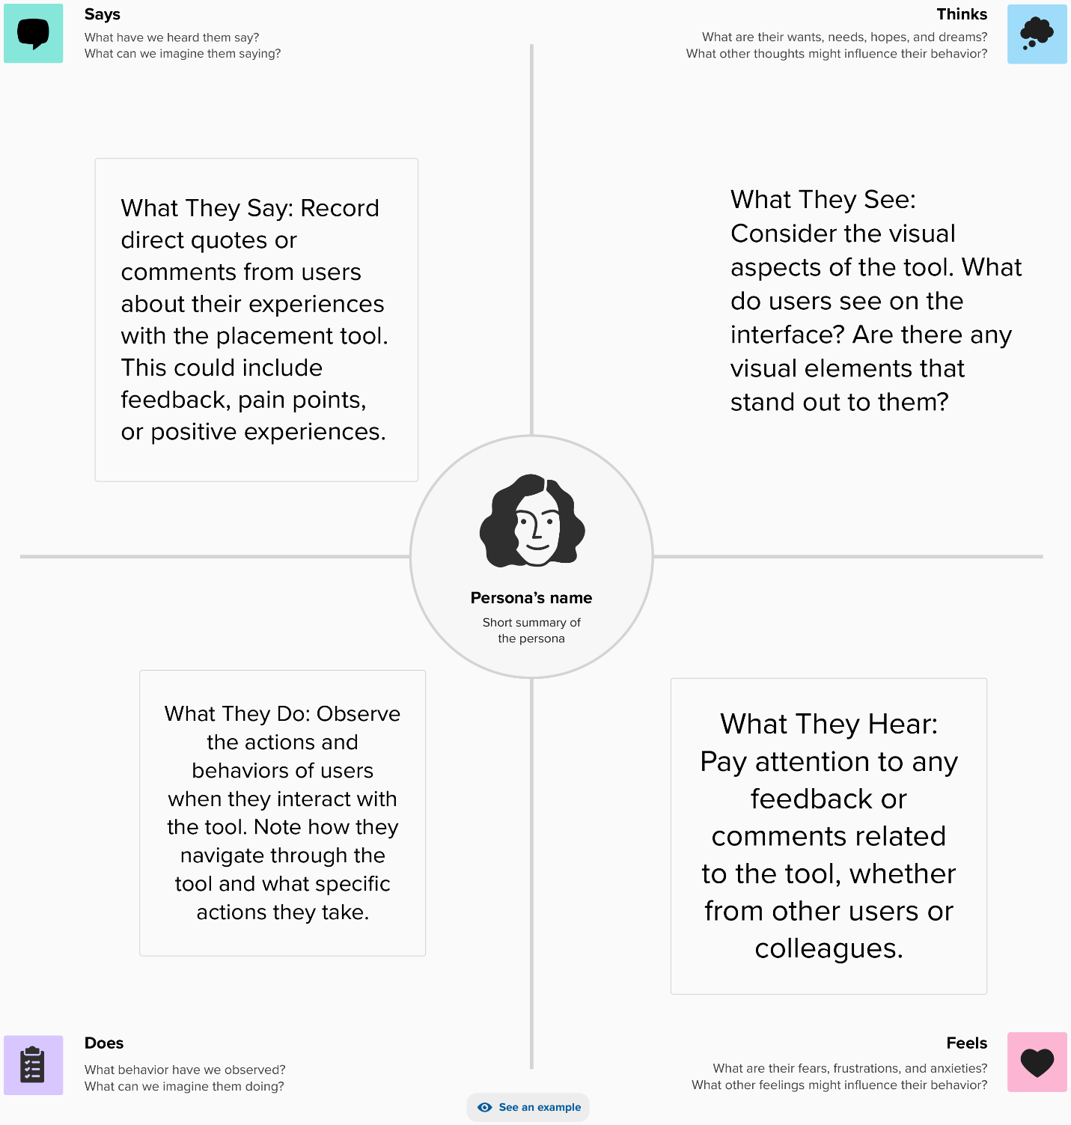

**FIG1 :SYSTEM DIAGRAM**

**3.2 IDEATION &BRAINSTORMING:**

The project aim is to develop Online Training and Placement system.The training and placement system gives more easiness to the users so that they can add and retrieve information quickly. Once user opens this system all the schedule/events are available to everyone. There are six types of user admin, current student, alumni, training and placement officers, training and placement staff, departmental staff and companies. The administrator is the master user having most of priorities than other users and has different functions like updating, viewing and approval for various application forms. Page Layout There is two types of student current student and alumni. The current student can view and enter information i.e. do registration edit their CV's online, update them constantly. Student can very flexibly search for and view company and vacancy details. A separate registration and profile will be done for alumni student. Alumni are kept in contact by an automated notification by email messages or SMS .They can post queries, reply queries, this will be helpful for current students. The administrator provides access to different users like TPO, TnP staff and departmental staffs each are provided with different features and security. TPO give an approval to edited information by the student, search the eligible student based on company criteria and can generate the list send email to eligible student. The company have to get register so that their information like the URL, contact, information, paper, vacancies will be provided. The web server to manage a performance the TnP activities efficiently. The database stores the whole data related to TnP system. Automated email system or SMS is used to notify the each student and other modules of system. the forum is platform provided to all users for communication to each other

**CHAPTER 4**

**REQUIREMENT ANALYSIS**

This project examines In designing a new system, the system analyst must have a clear understanding of the objectives, which the design is aiming to fulfill. The first step is to determine how the output is to be produced and in what format. Second, input data and master files have to be designed to meet the requirements of the proposed output. The operational phases are handled through program construction and testing. Design of the system can be defined as a process of applying various techniques and principles for the purpose of defining a device, a process or a system in sufficient detail to permit its physical realization. This system design is a solution to “how to” approach to the creation of a new system. This important phase provides the understanding and the procedural details necessary for implementing the system recommended in the feasibility study. The design step provides a data design, architectural design, and a procedural design

**4.1FUNCTIONAL REQUIREMENT:**

**Data Collection:** Collect literacy rate data from local colleges.

**Data Analysis:** Analyze the collected data to identify the year of the students.

**Resource Allocation:** Allocate resources for educational materials and training materilas.

**Community Engagement:** Engagement programs to involve the community initiatives.

**Monitoring and Evaluation:** Implement a system for tracking progress and evaluating the impact of Trained Students.

**4.2 NON FUNCTIONAL REQUIREMENT:**

**Timeline**: Define project timelines and milestones.

**Budget:** Determine the budget for the initiative, including funding sources.

**Scalability:** Ensure that the strategies can be scaled to benefit a larger population.

**Sustainability**: Develop plans for the long-term sustainability of programs.

**Data Security:** Implement measures to protect sensitive data, such as student information.

**CHAPTER 5**

**PROJECT DESIGN**

**5.1 DATA FLOW DIAGRAM &USER STORIES:**

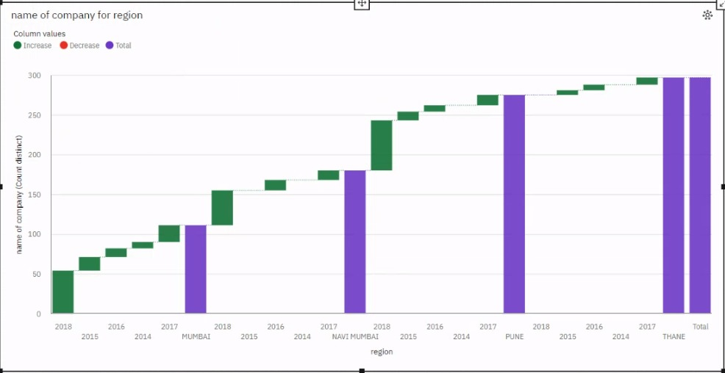

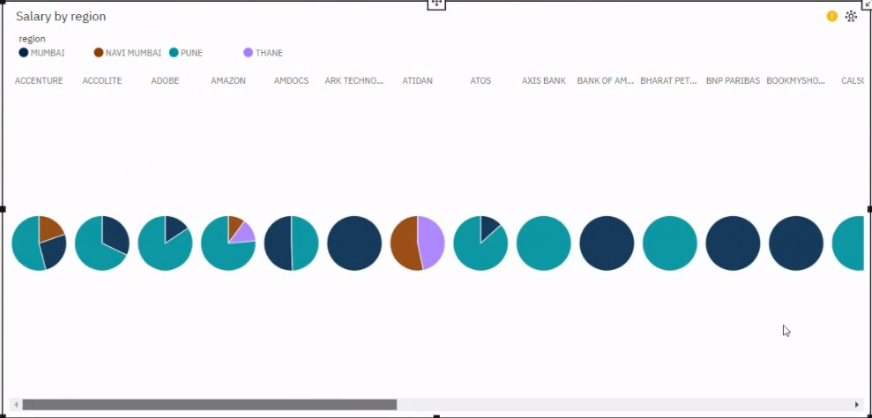

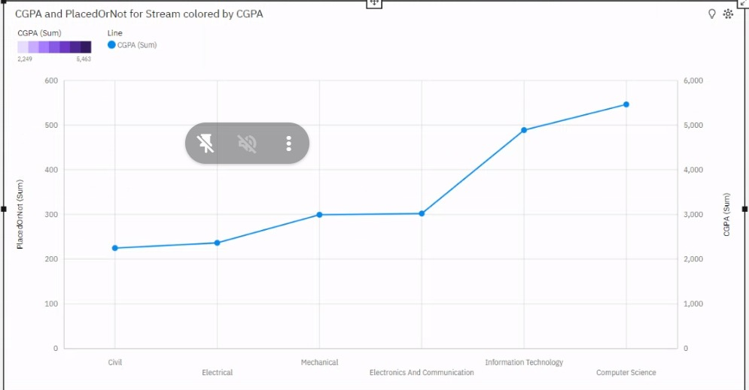

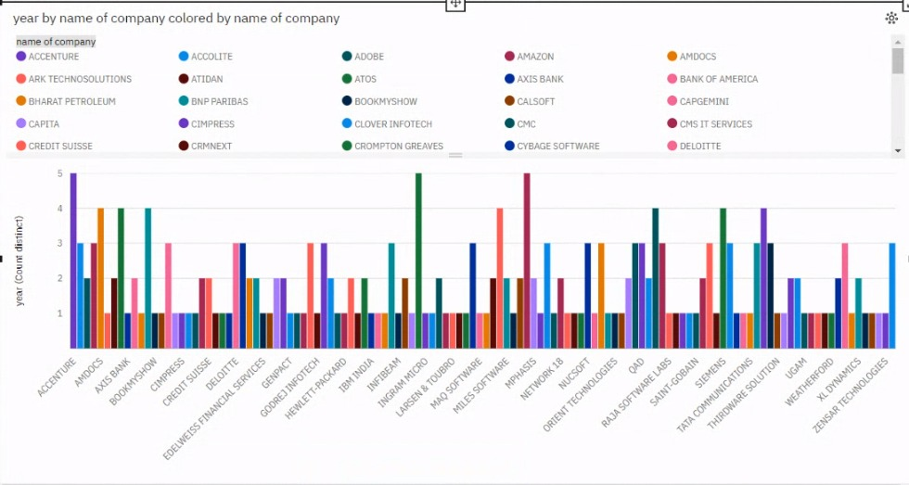

**FIG 2: DATAFLOW DIAGRAM**

**5.2 SOLUTION ARCHITECTURE:**

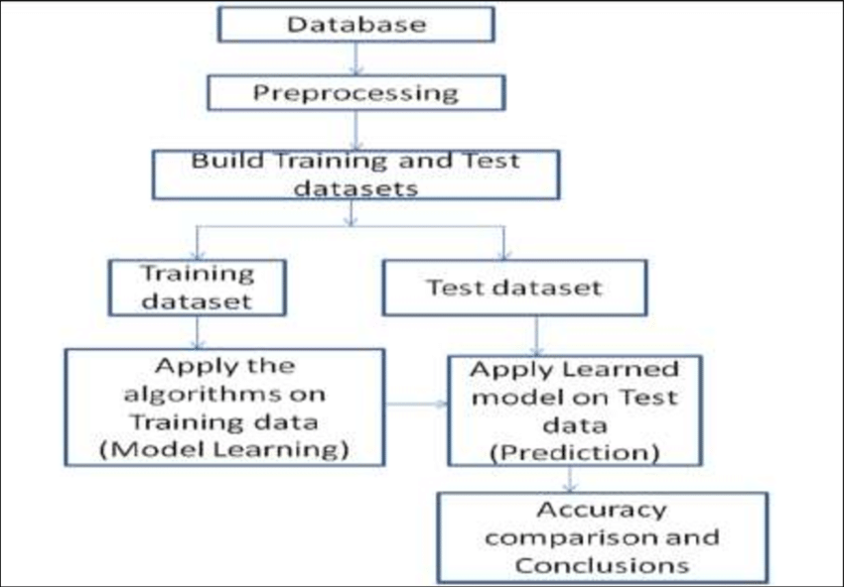

**CHAPTER 6**

**PROJECT PLANNING SCHEDULING**

**6.1 TECHNICAL ARCHITECTURE:**

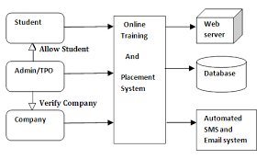

**FIG3 : TECHNICAL ARCHITECTURE**

**6.2 SPRINT PLANNING &ESTIMATION:**

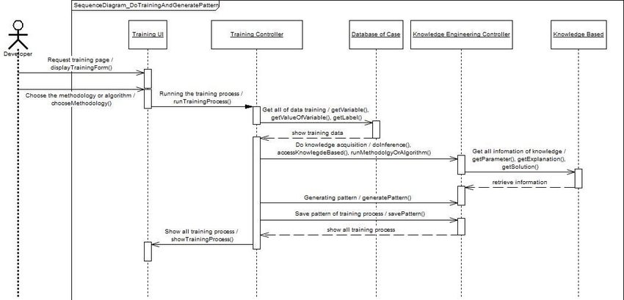

**FIG4 : SPRINT PLANNING &ESTIMATION DIAGRAM**

**6.3 SPRINT PLANNING &ESTIMATION:**

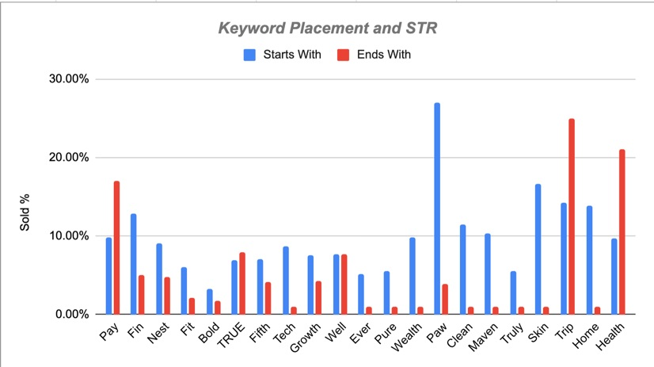

**FIG5: SPRINT PLANNING &ESTIMATION DIAGRAM**

**CHAPTER 7**

**CODING & SOLUTION**

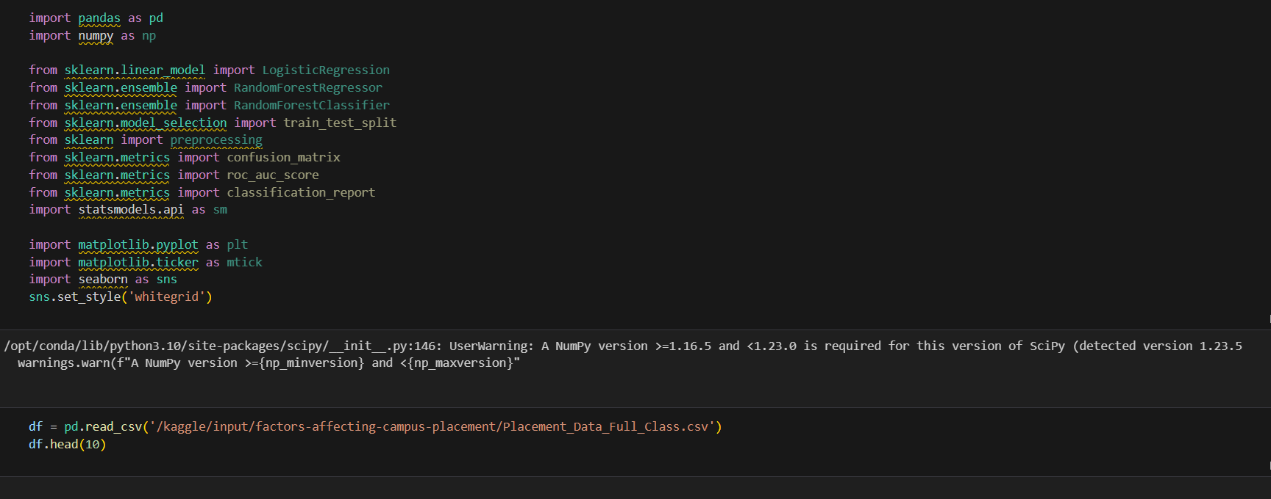

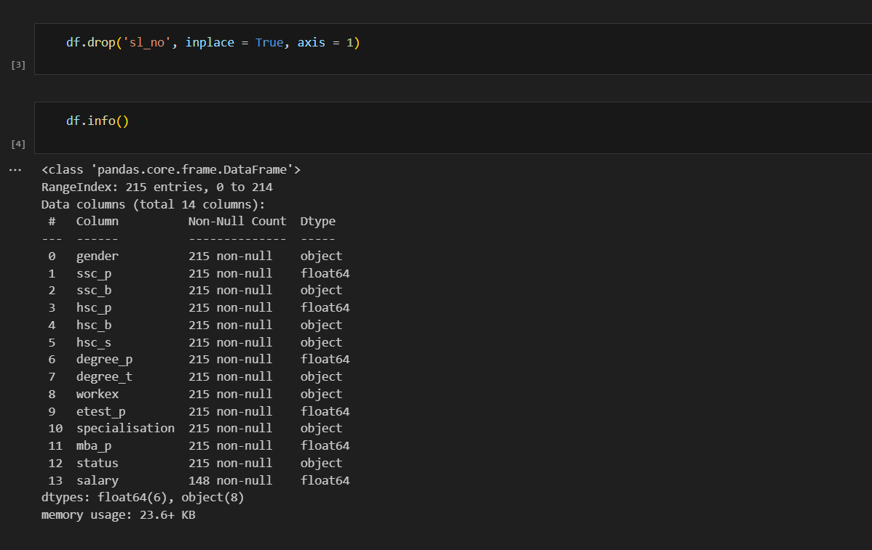

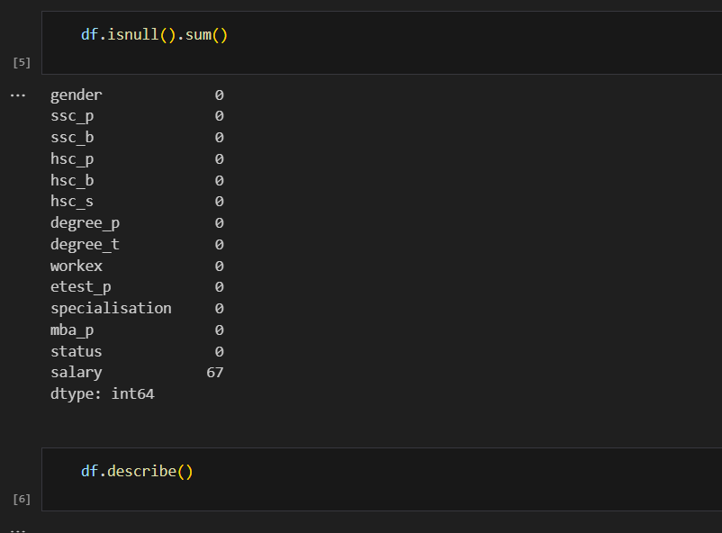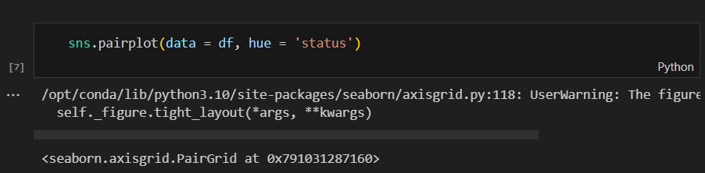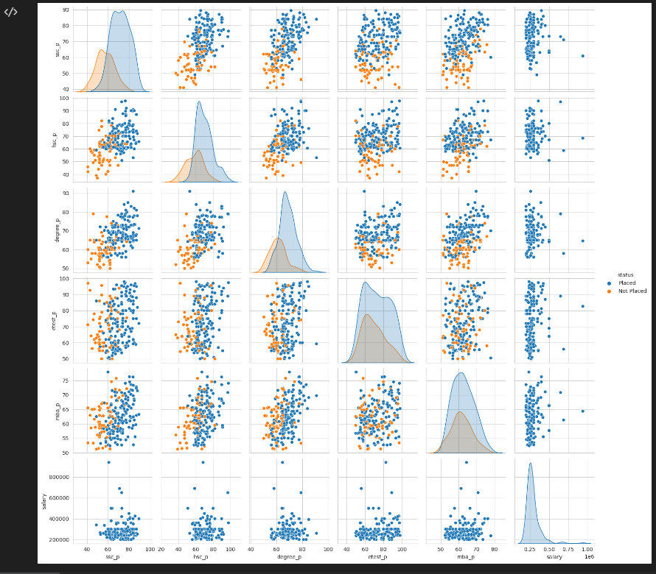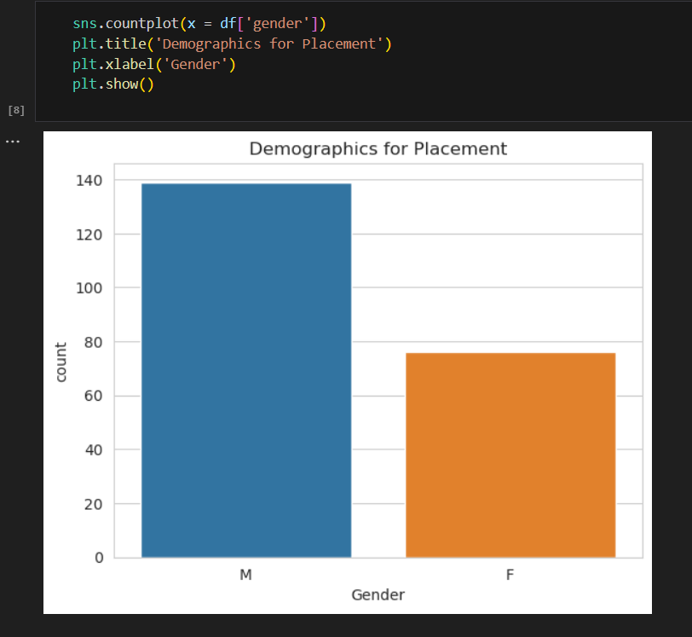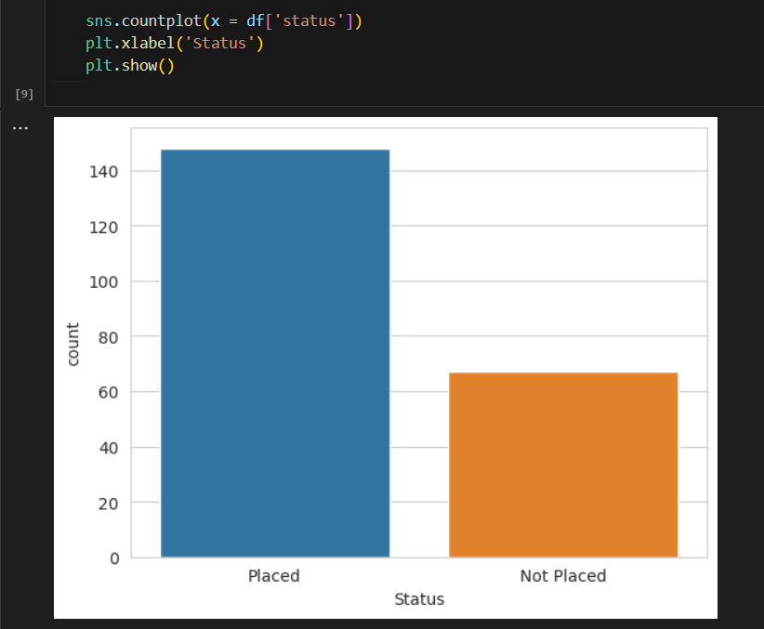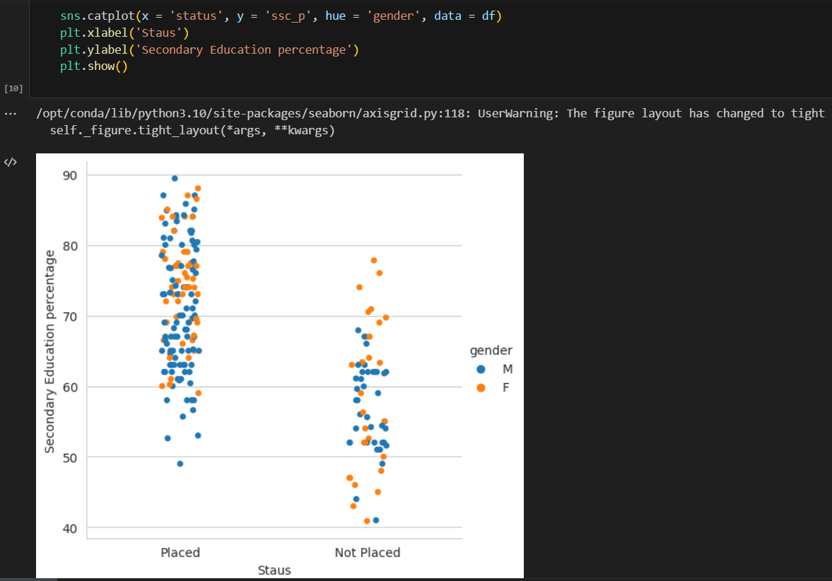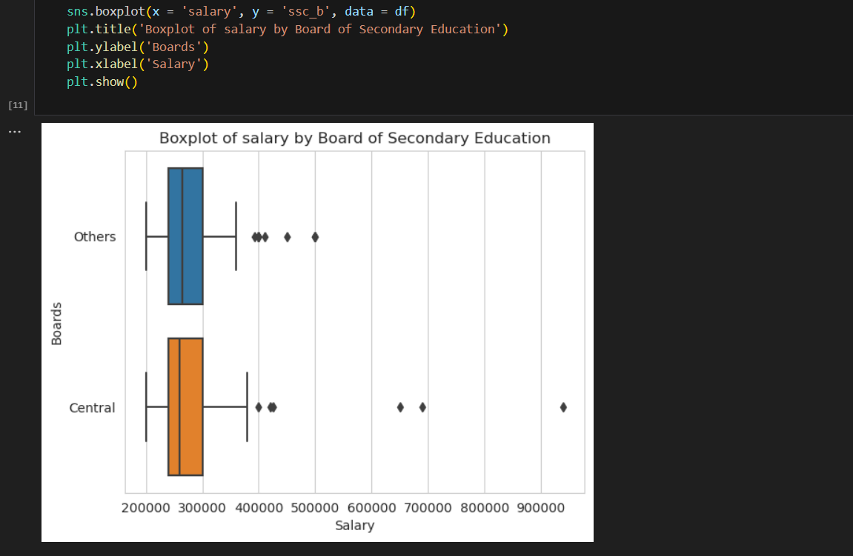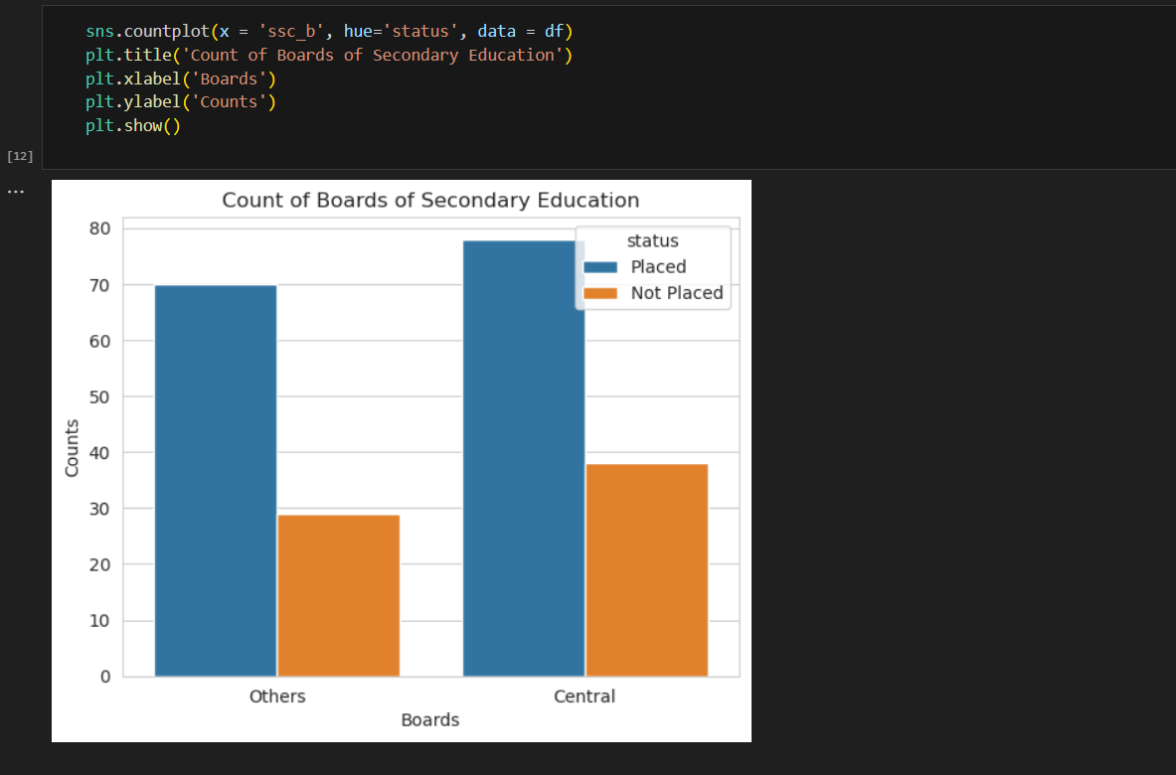

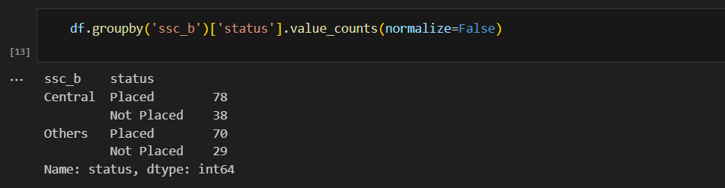

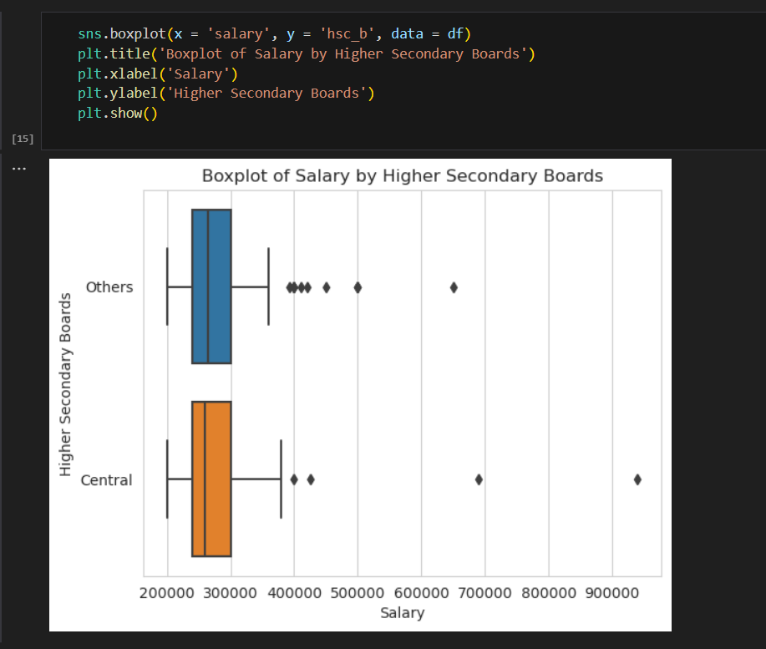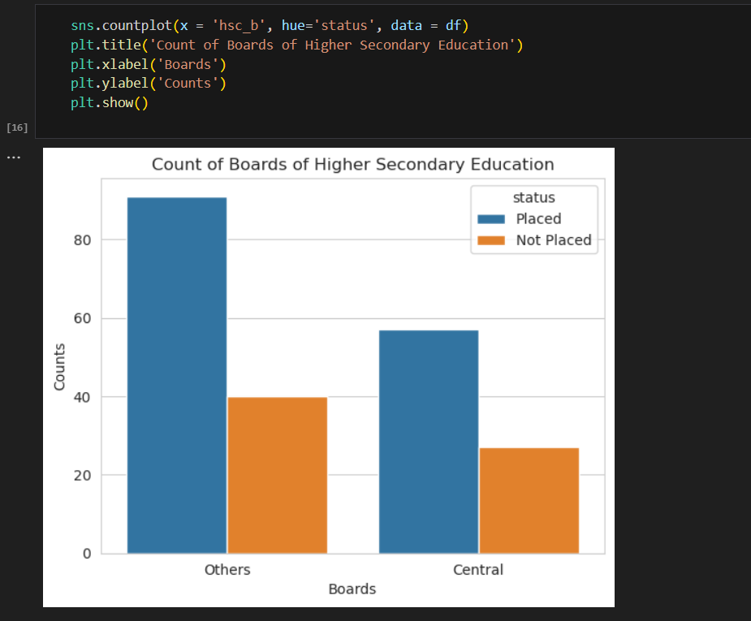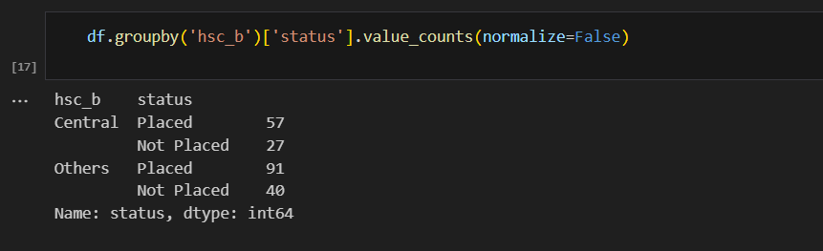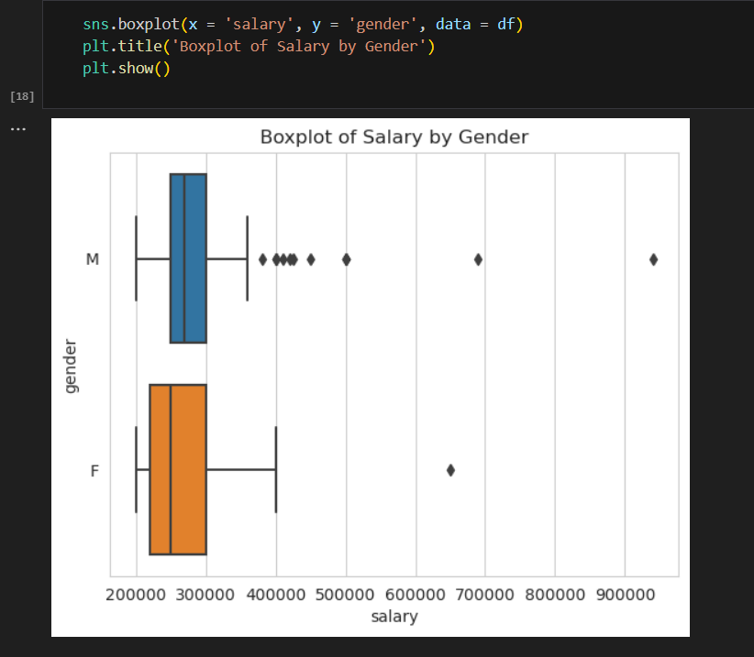

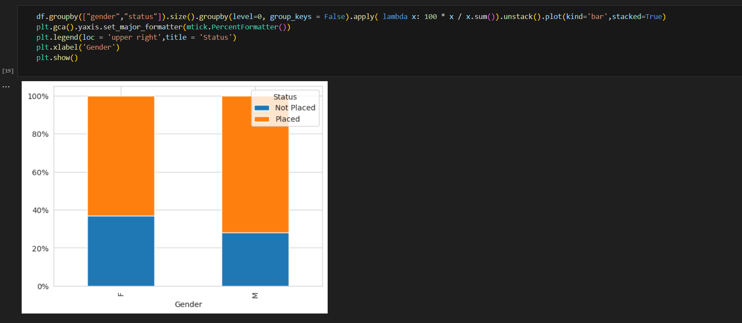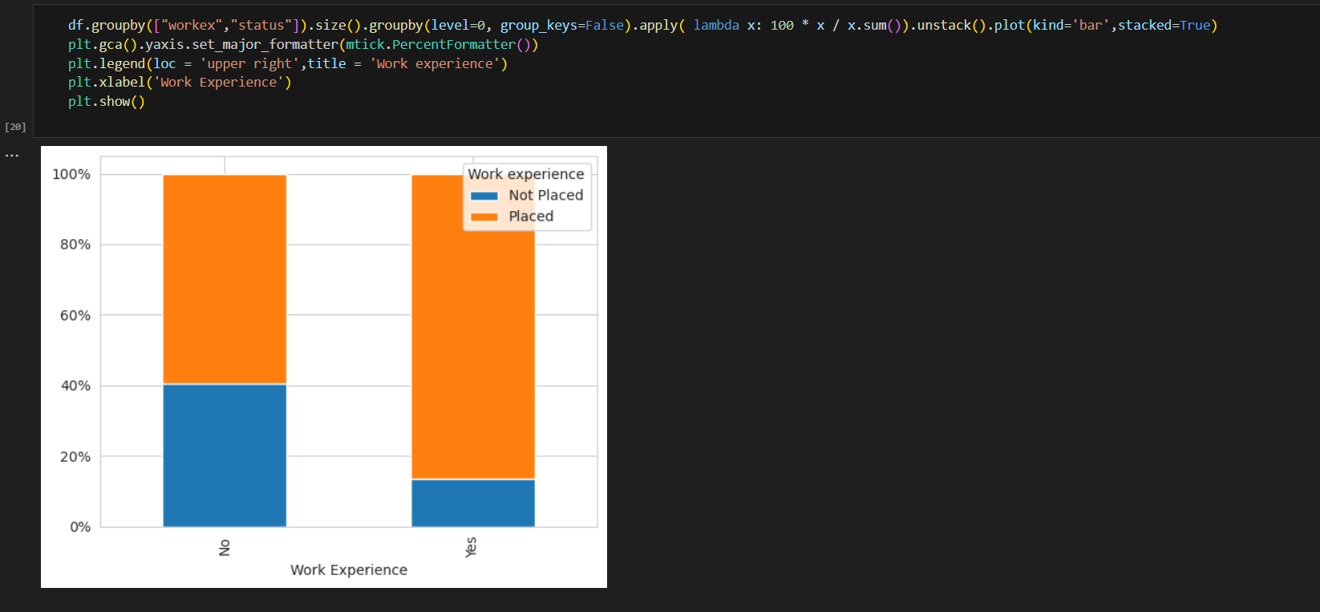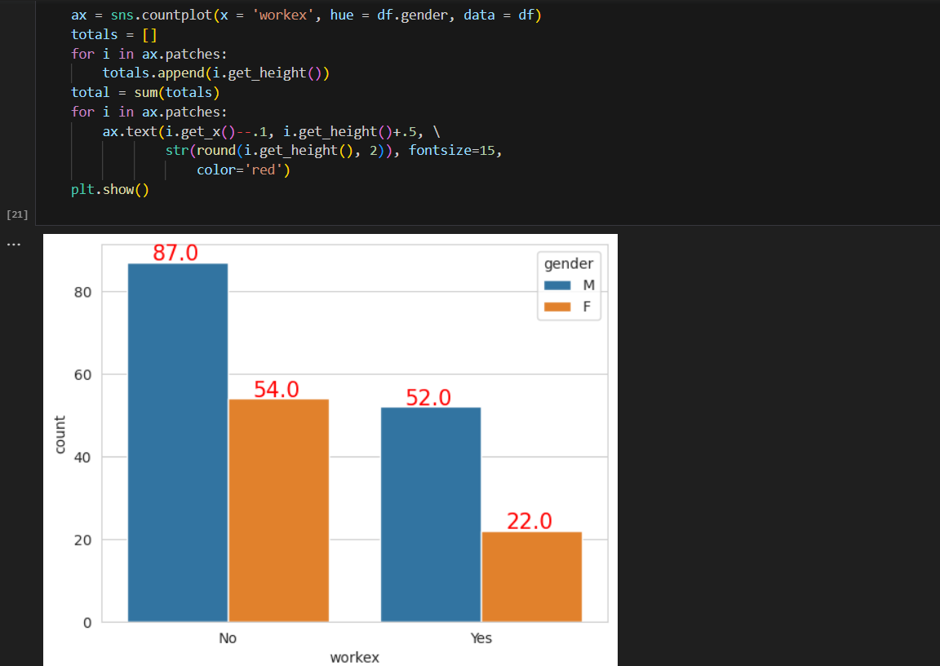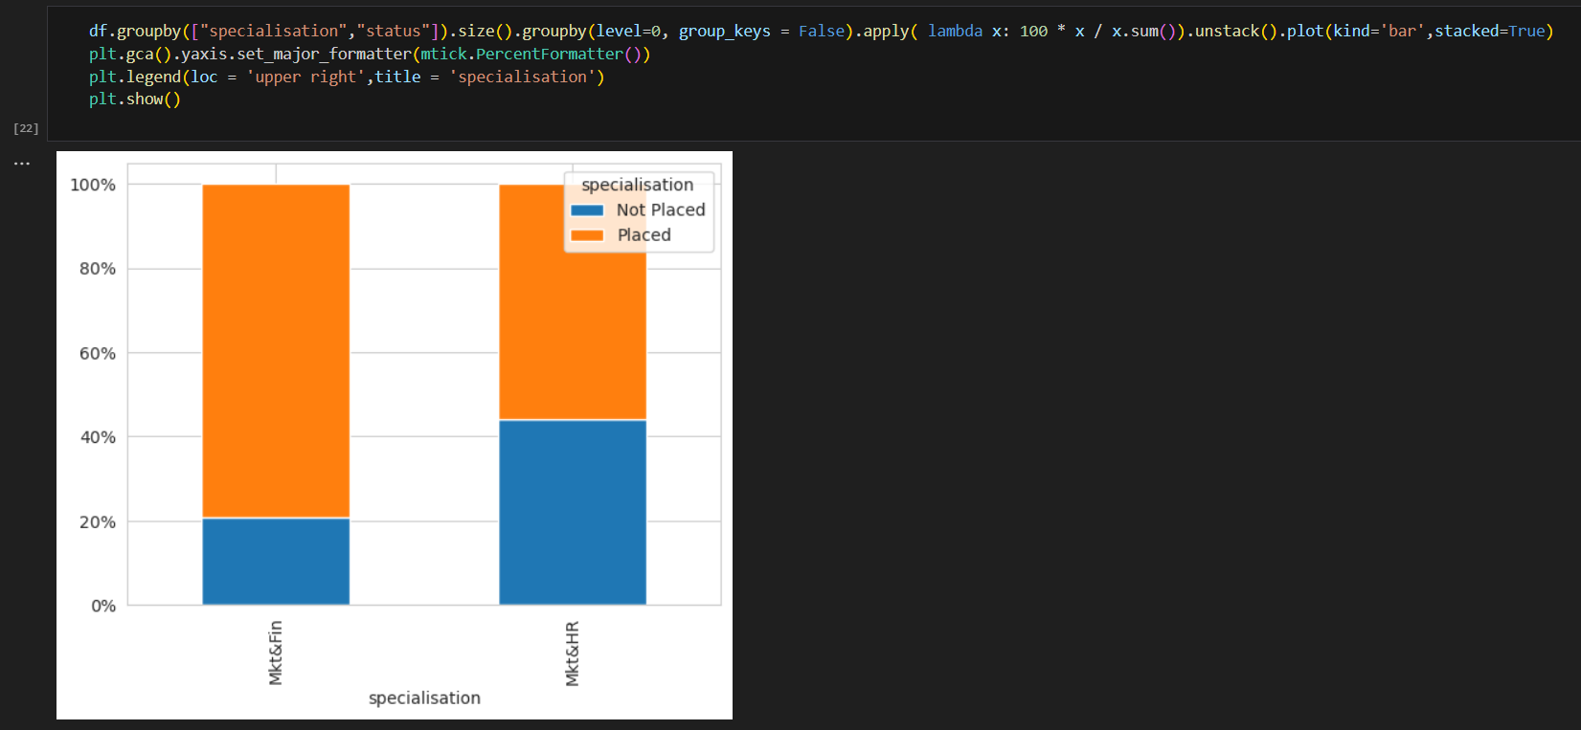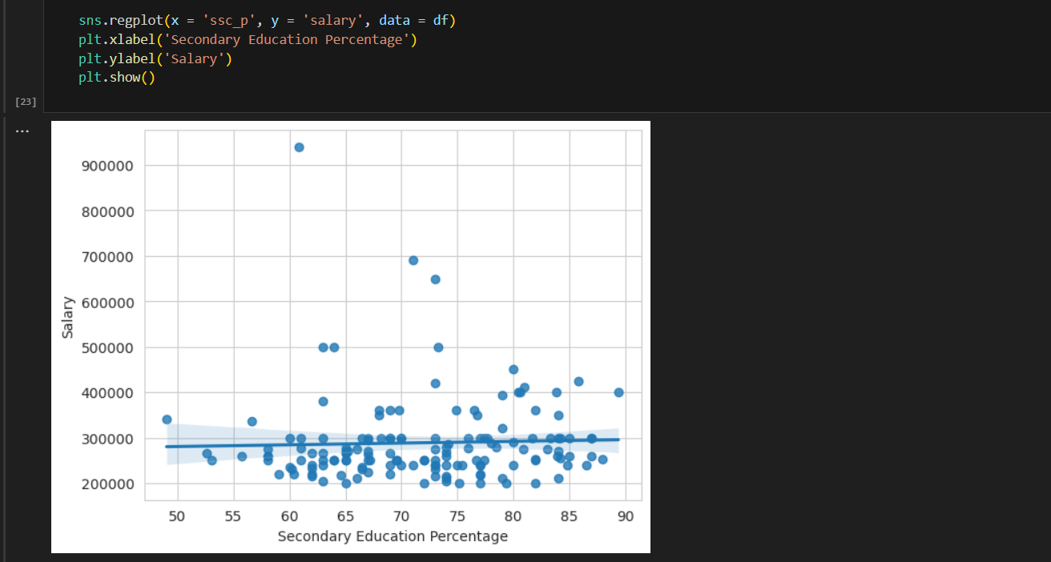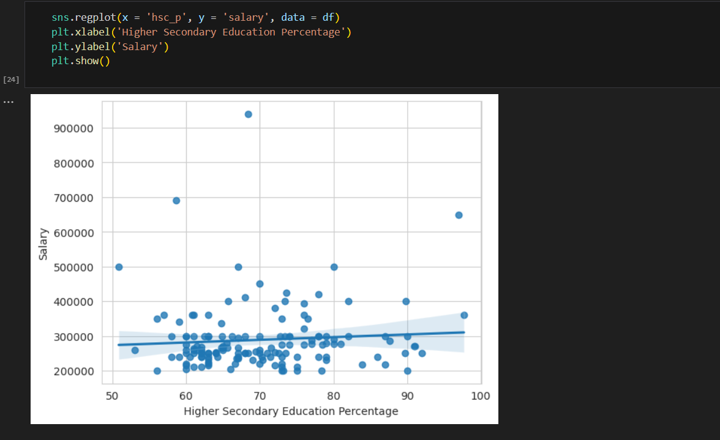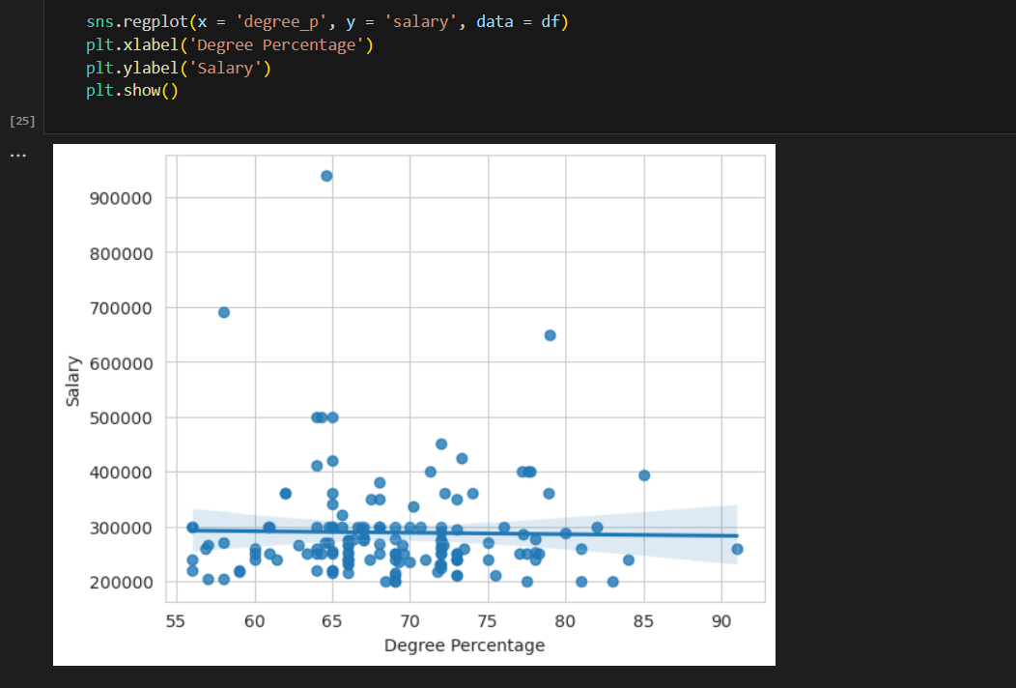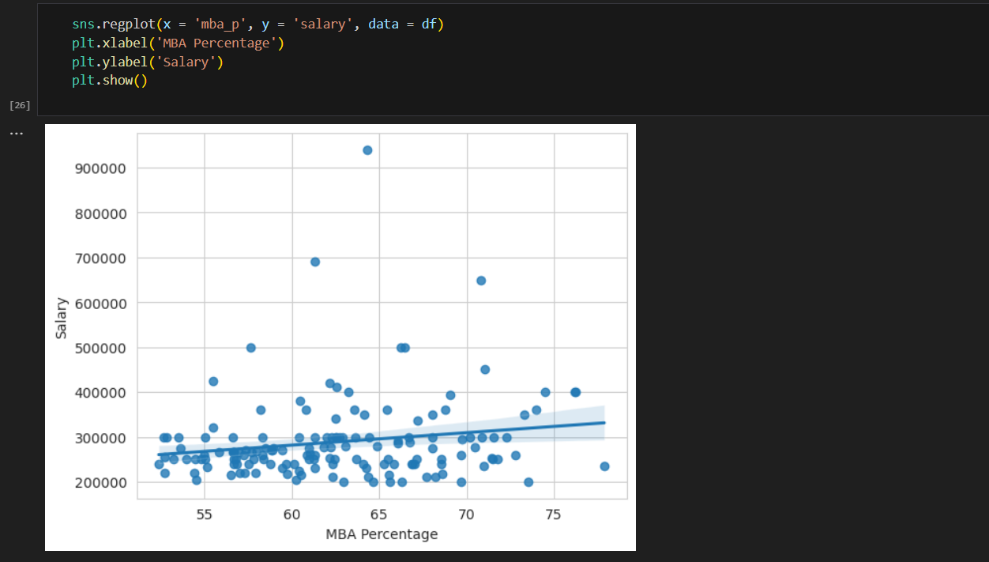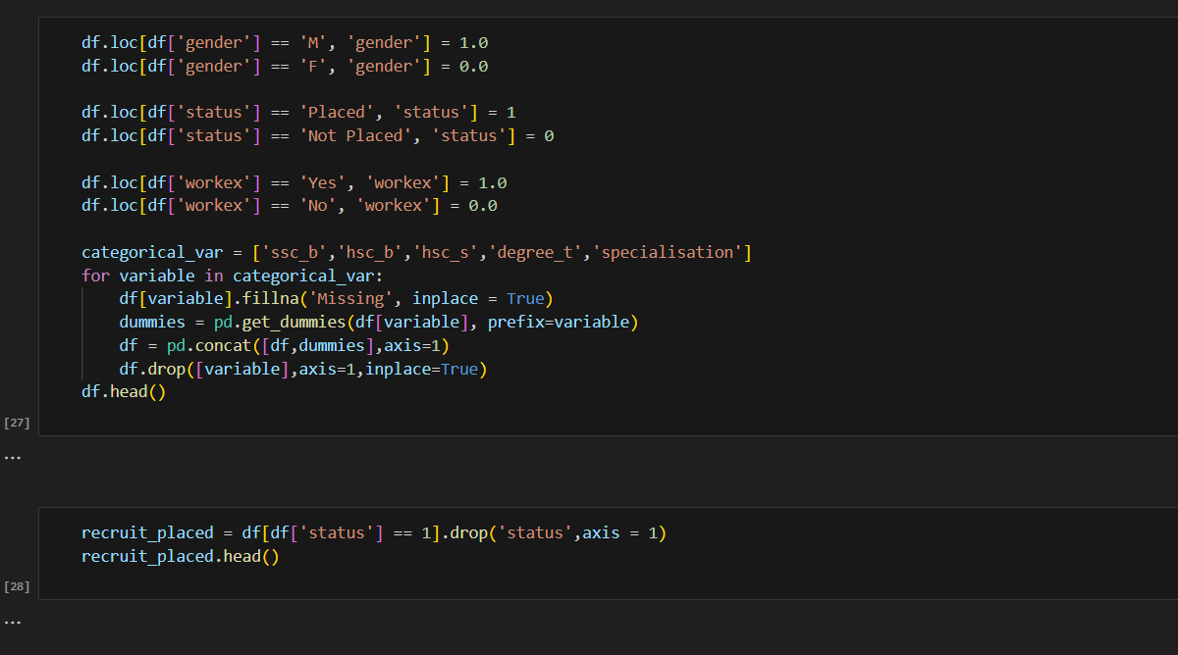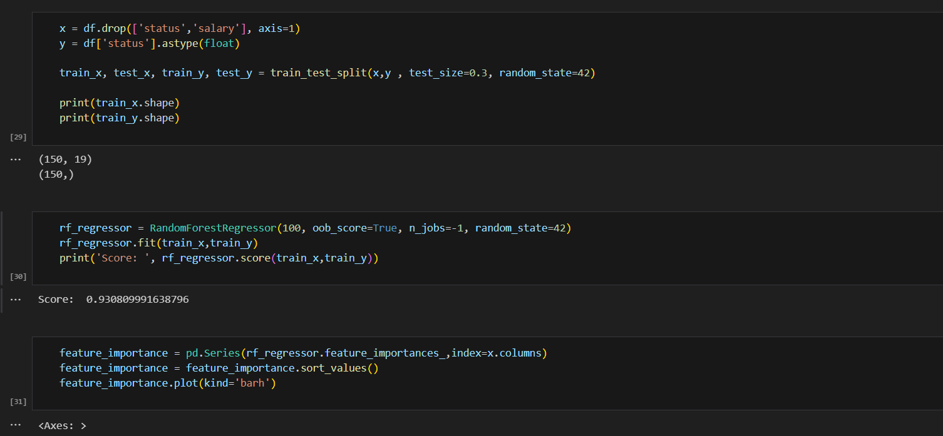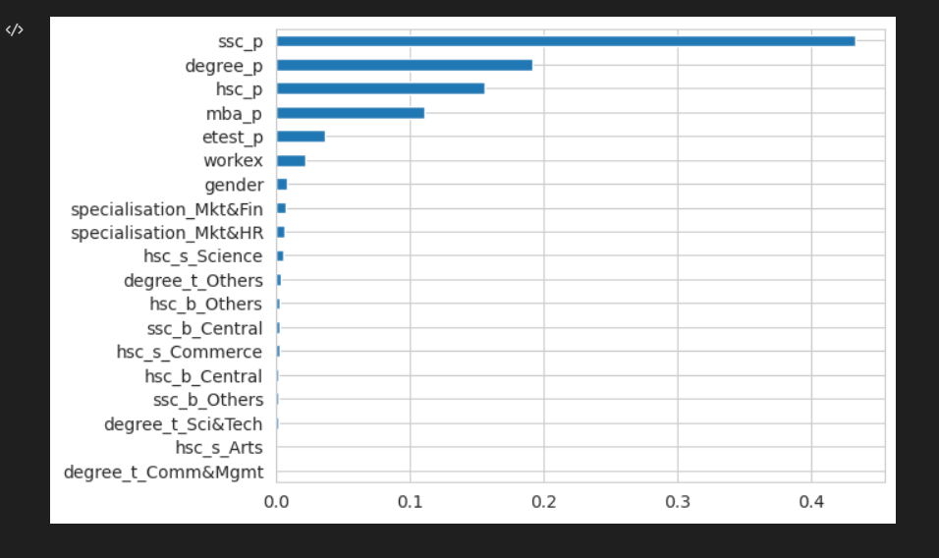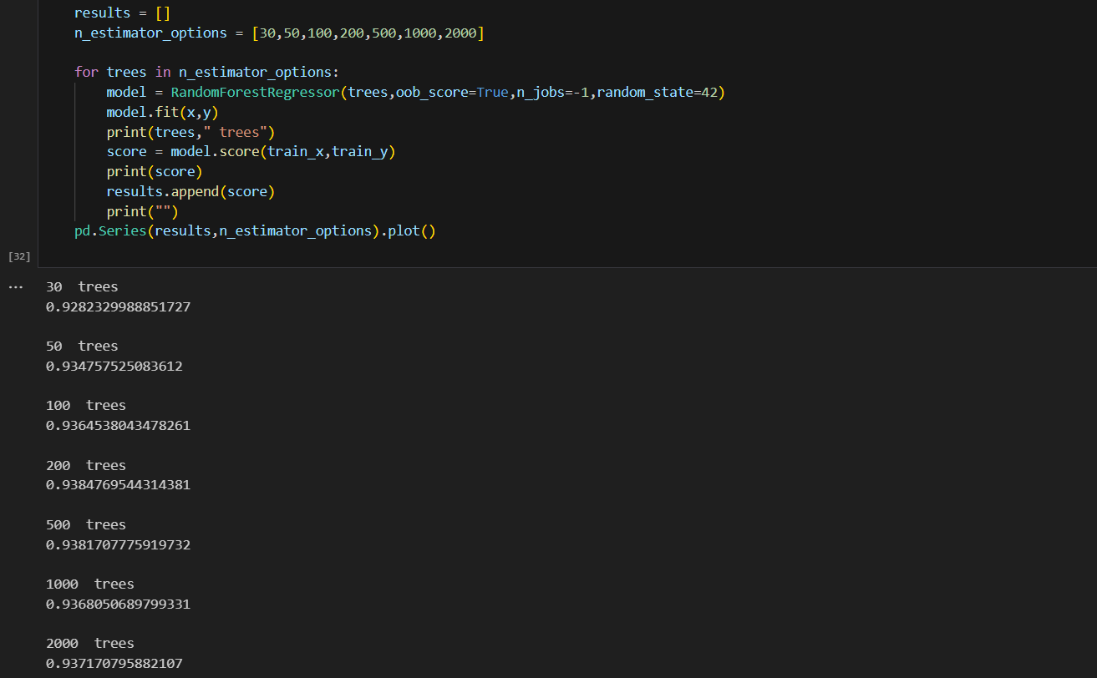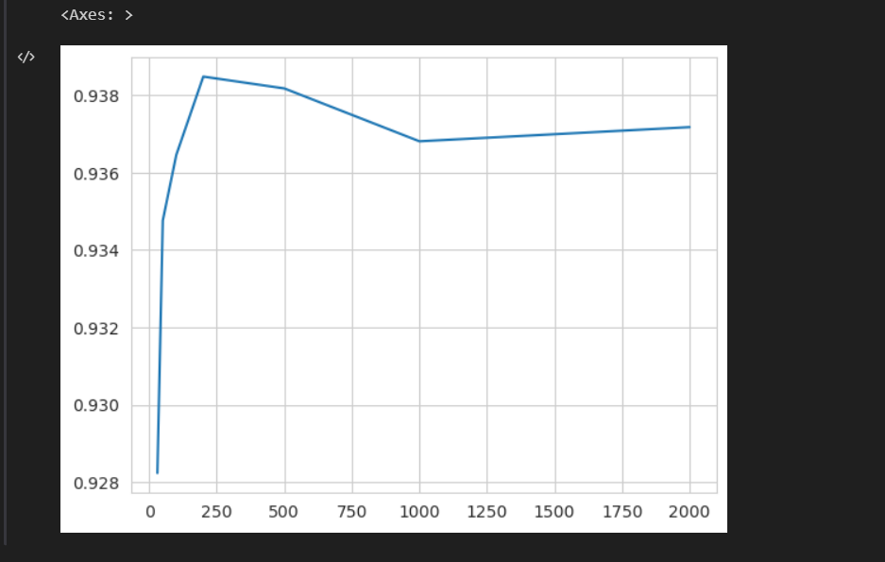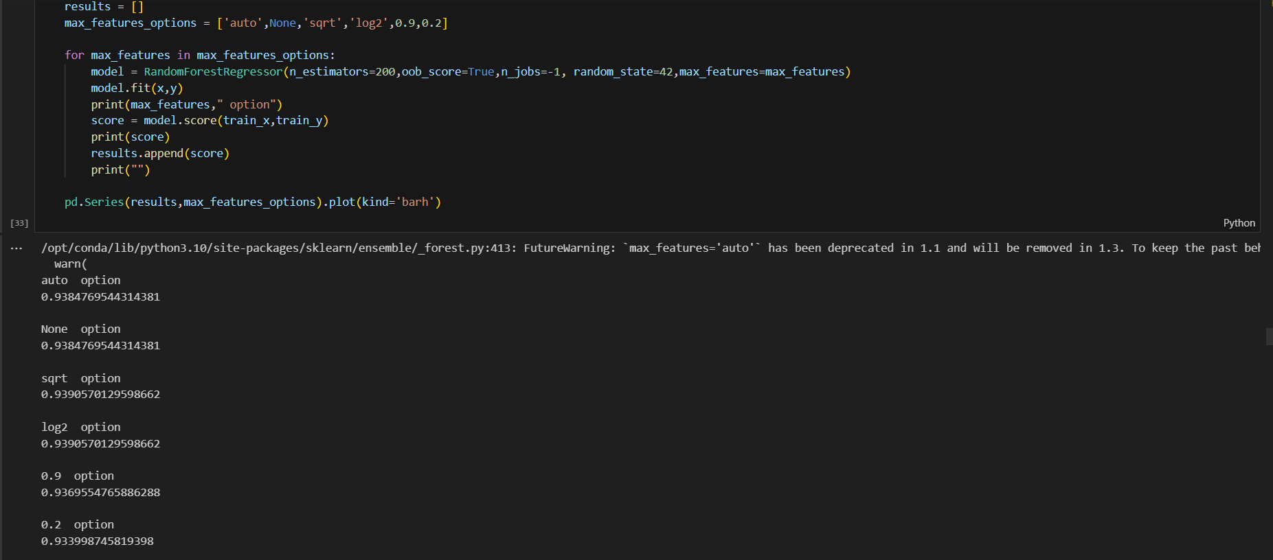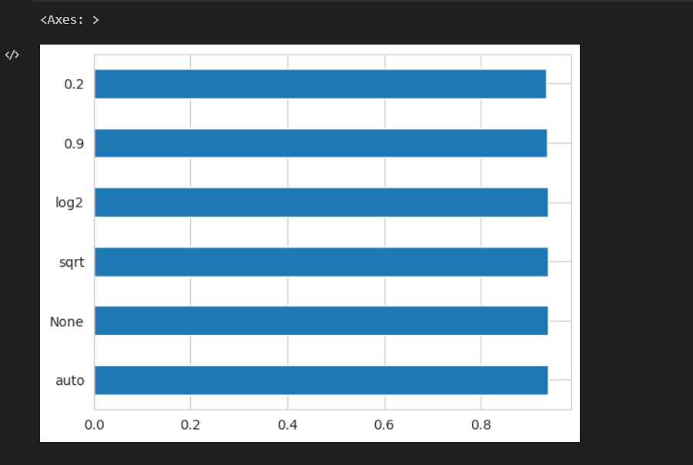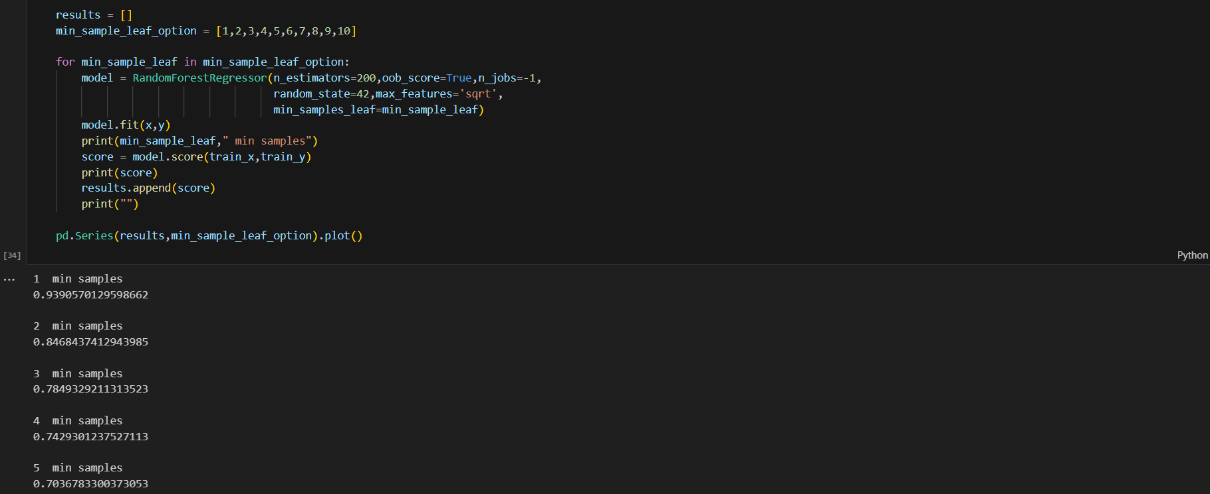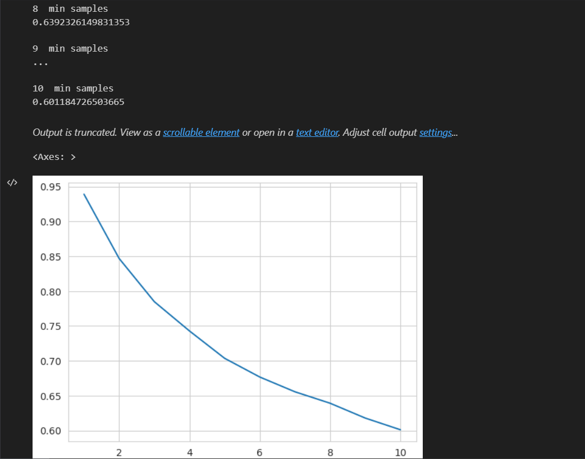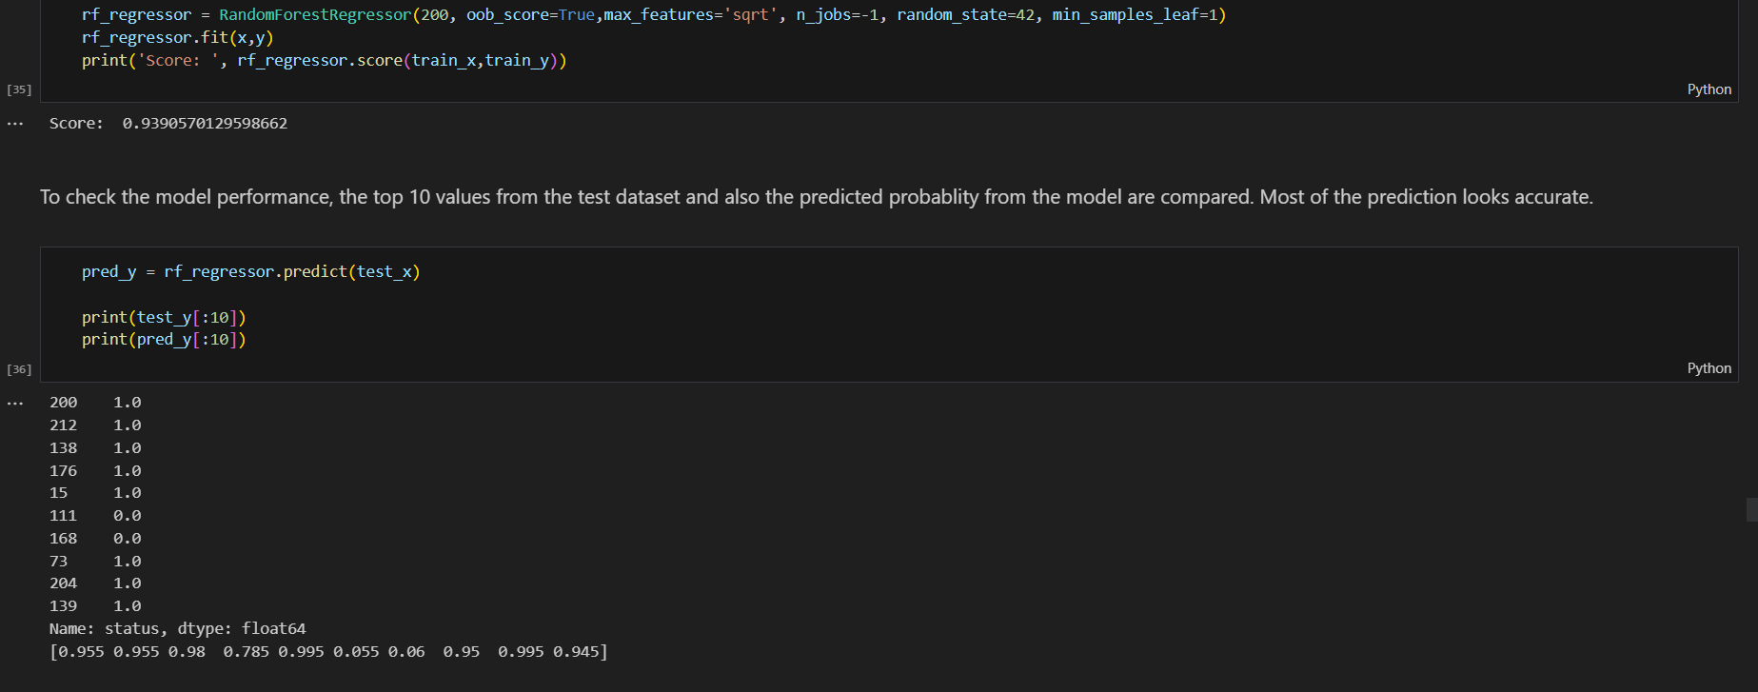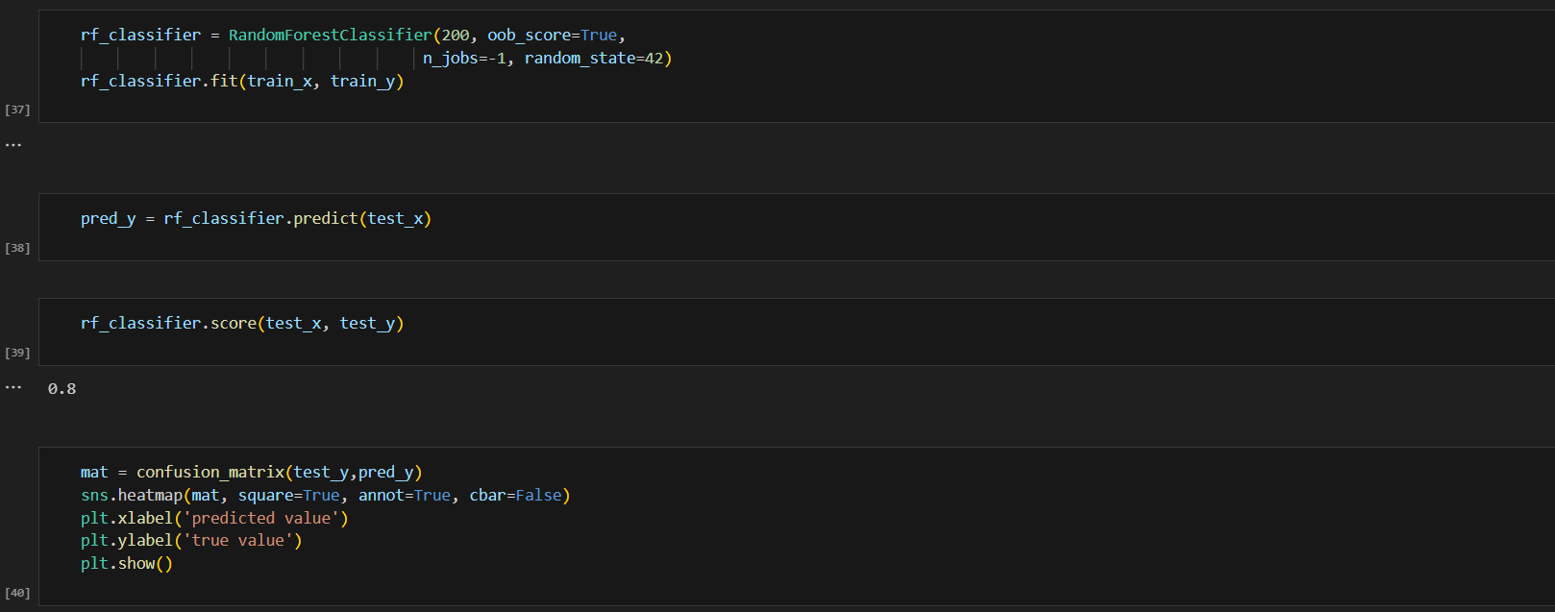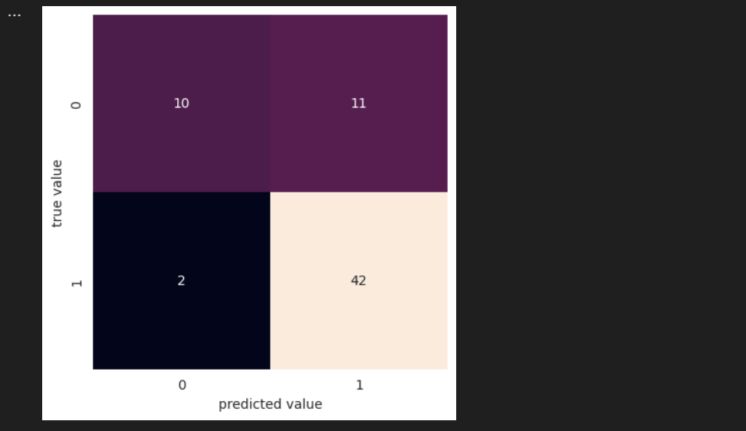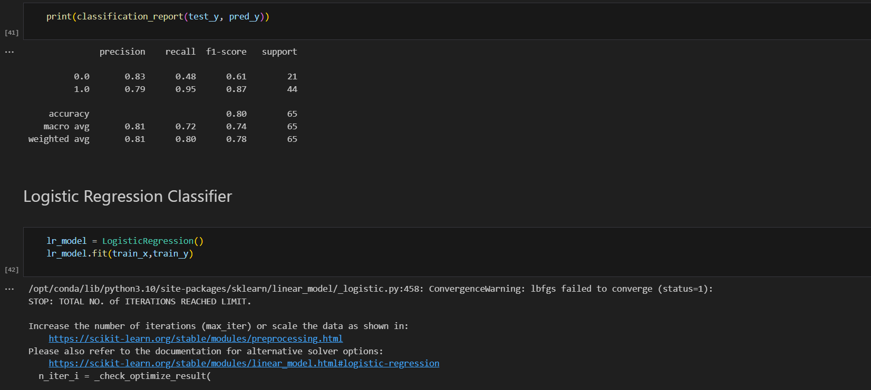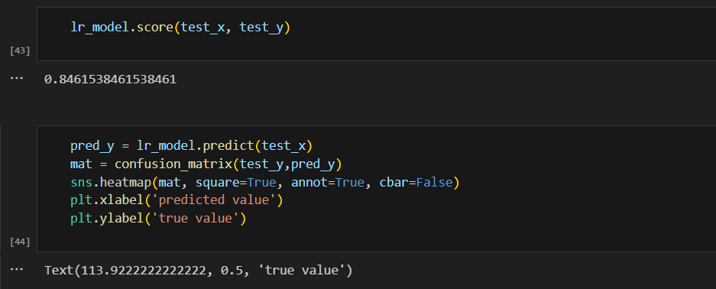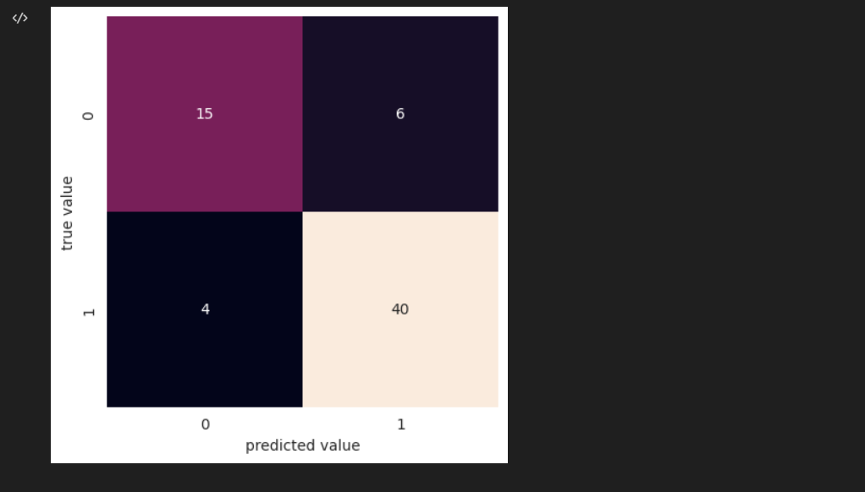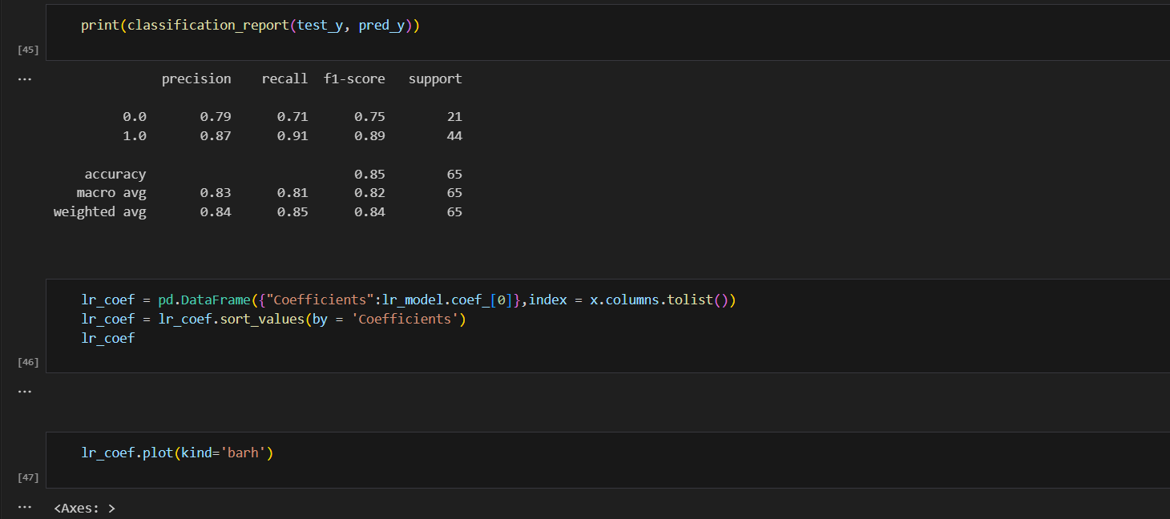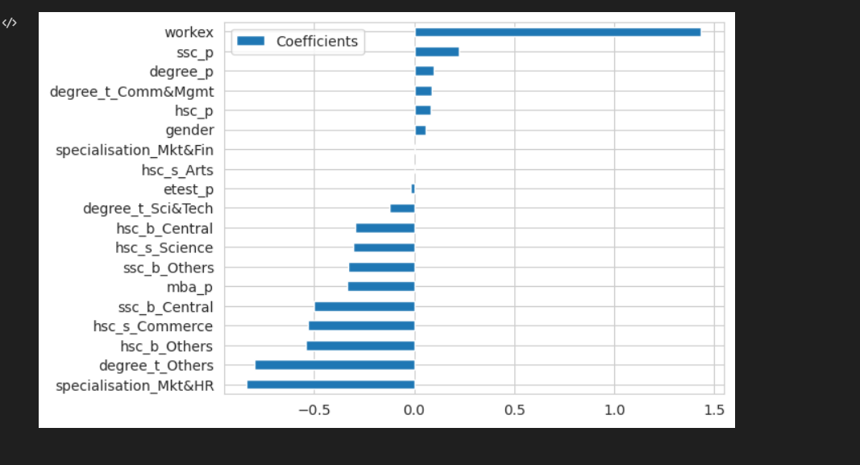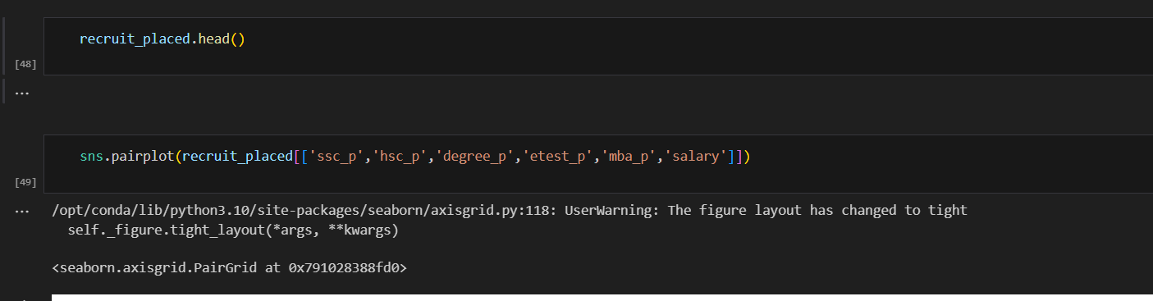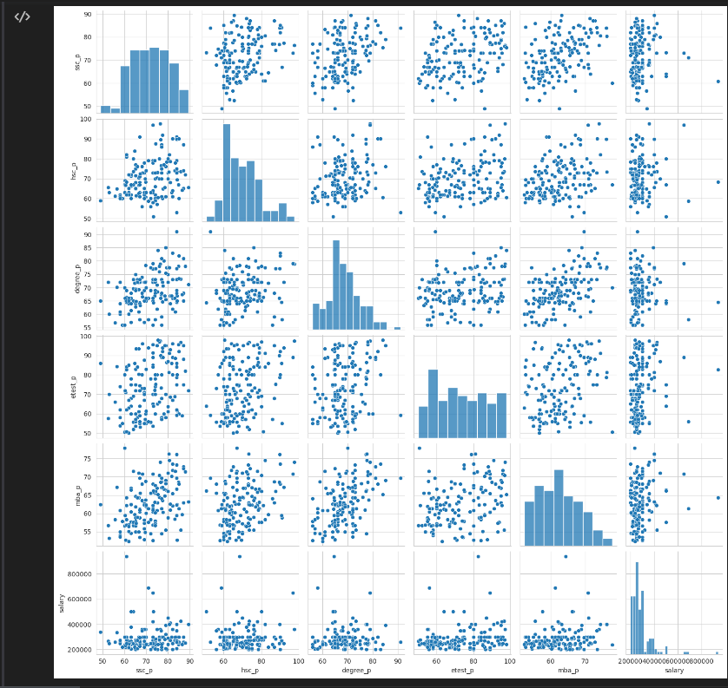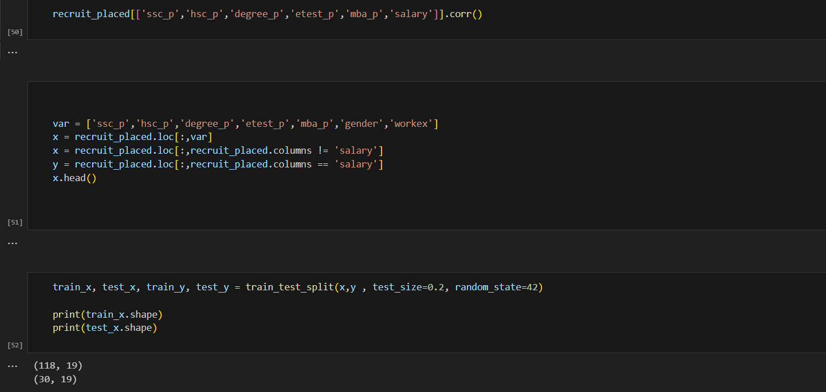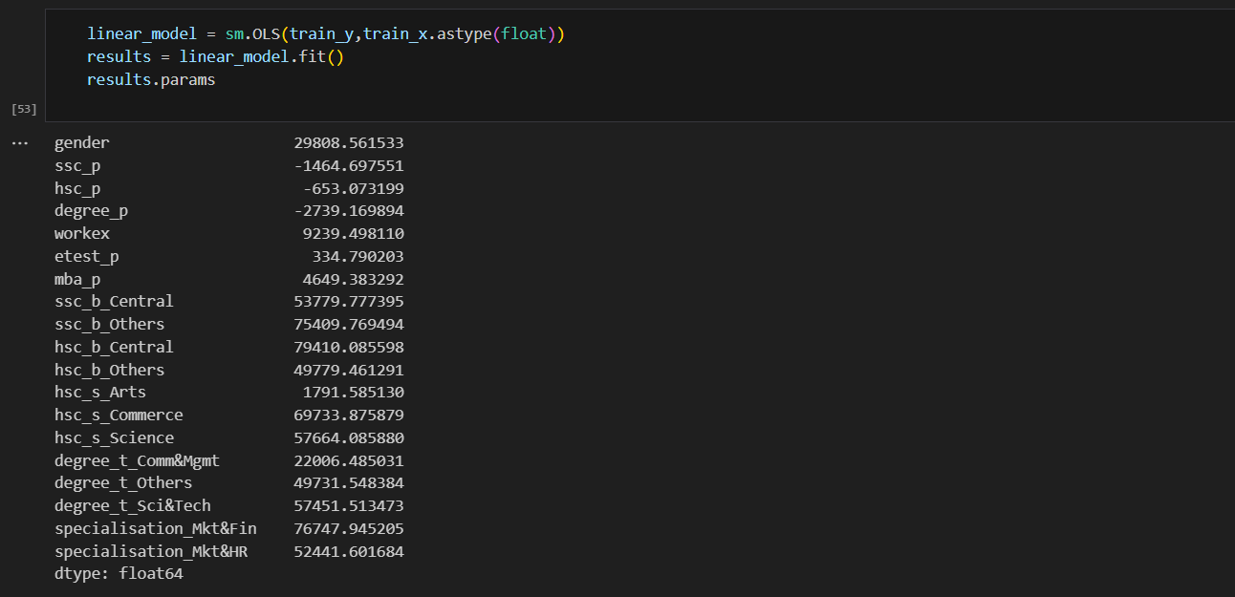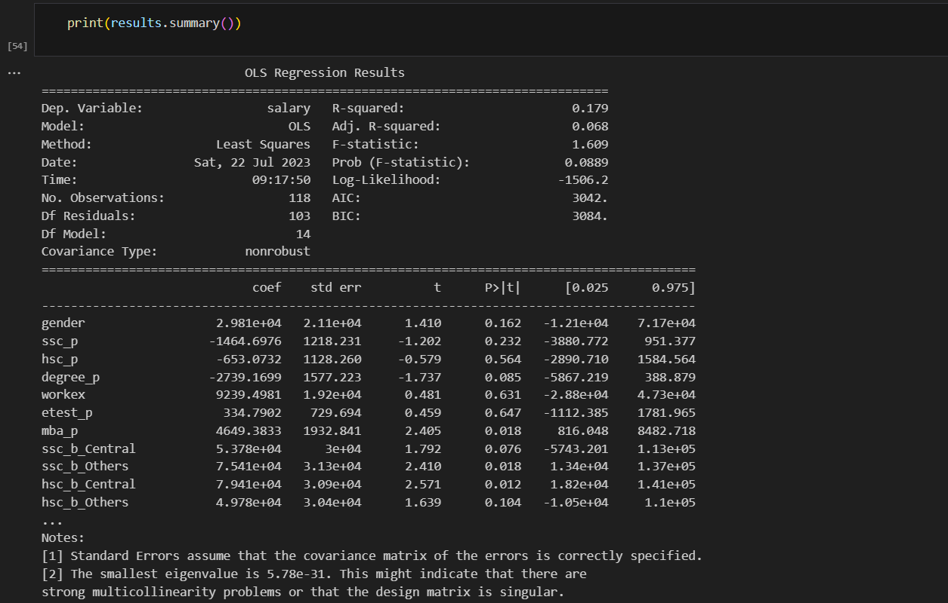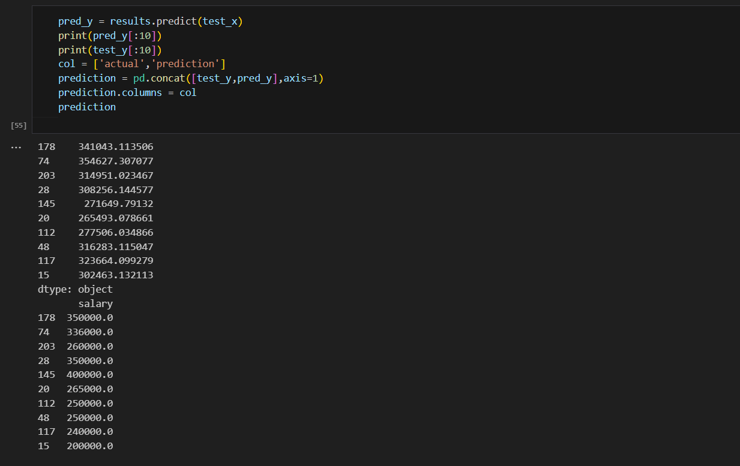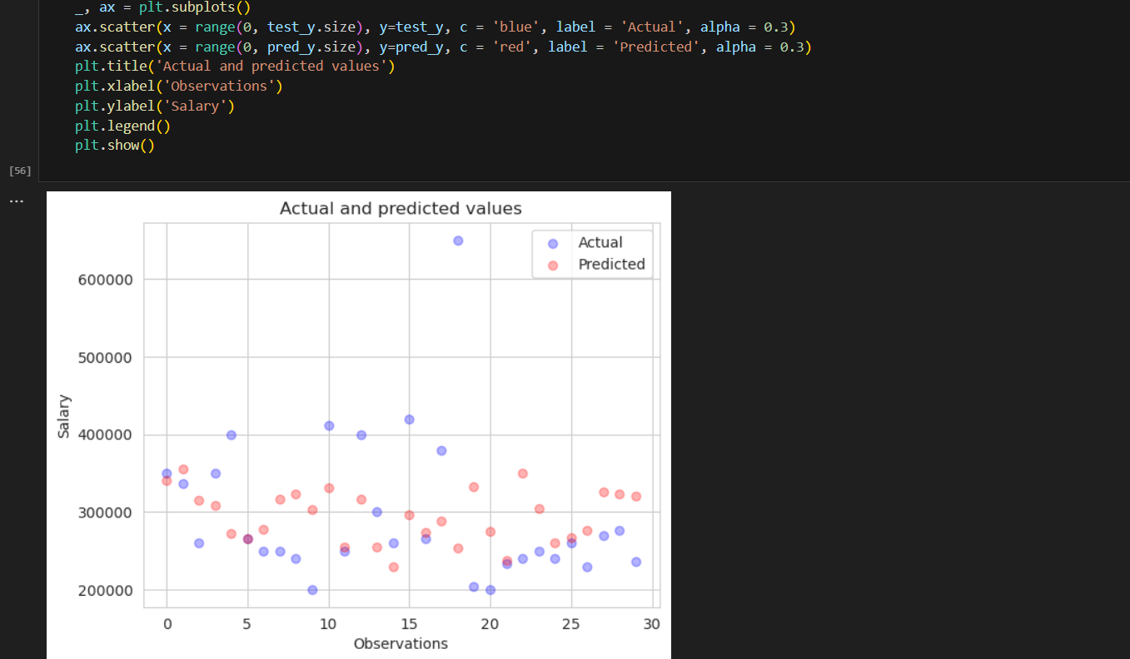

**CHAPTER 8**

**PERFORMANCE TESTING**

Performance testing is crucial for ensuring that a system or solution designed to empower the future through literacy rate analysis functions optimally and meets its goals. To measure the performance of such a system, you need to define relevant performance test metrics. Here are some performance test metrics for your literacy rate analysis project:

Response Time: This measures the time it takes for the system to respond to a user's request. Short response times are critical for an effective user experience, especially for accessing educational resources and data analysis tools.

Throughput: Throughput indicates how many requests or transactions the system can handle per unit of time. It's important to ensure that the system can support a sufficient number of users accessing educational resources simultaneously.

Concurrency: Assess the system's ability to handle multiple users concurrently. This metric is especially relevant if you expect a large number of users trying to access resources or data analysis tools simultaneously.

Resource Utilization: Monitor the utilization of hardware resources (CPU, memory, storage) during peak usage. Efficient resource usage ensures cost-effectiveness and a stable system.

Error Rate: Measure the number of errors or failed transactions during a test. Minimizing errors is vital for a positive user experience.

Scalability: Test the system's ability to scale with increasing loads. Scalability metrics will help determine when additional resources or infrastructure are needed to support growth.

Latency: Analyze the delay in processing requests. Low latency is crucial for real-time access to educational materials and data analysis results.

Network Performance: Assess network-related metrics, including bandwidth usage and data transfer rates. This is important for users accessing resources remotely.

Data Accuracy: Evaluate the accuracy of data analysis results, which is critical for making informed decisions and policies based on the literacy rate analysis.

User Satisfaction: Collect feedback from users to gauge their satisfaction with the system's performance and usability.

Load Testing: Determine how the system performs under both expected and extreme loads to understand its capacity and limitations.

Stress Testing: Push the system to its limits to identify breaking points and evaluate how it behaves under high stress conditions.

Availability and Reliability: Measure the system's uptime and reliability. Frequent downtime can disrupt access to educational resources and data analysis tools.

Security Testing: Verify the system's security features to protect user data and educational materials from breaches.

Scalability and Capacity Planning: Analyze how the system scales as usage increases and plan for future capacity needs.

Cost Efficiency: Assess the cost-effectiveness of the system's infrastructure and operations, including cloud service usage.

Environmental Impact: Consider the environmental impact of the infrastructure used, such as energy consumption, to align with sustainability goals.

It's essential to customize these metrics based on the specific goals and requirements of your literacy rate analysis project. Regular performance testing and monitoring will help you identify and address performance issues and ensure the system's effectiveness in empowering the future through improved literacy

**CHAPTER 9**

**RESULTS**

* 1. **OUTPUT SCREENSHOTS:**

**FIG : Placement Distribution based on Secondary**

**Education Percentage distinguished by Gender**

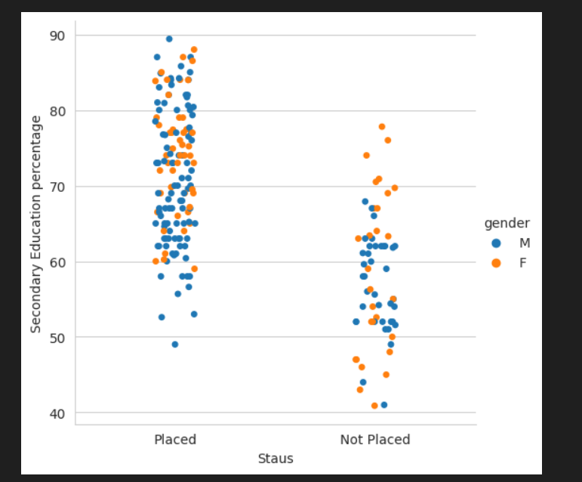

**FIG : Placement by Secondary Education Boards**

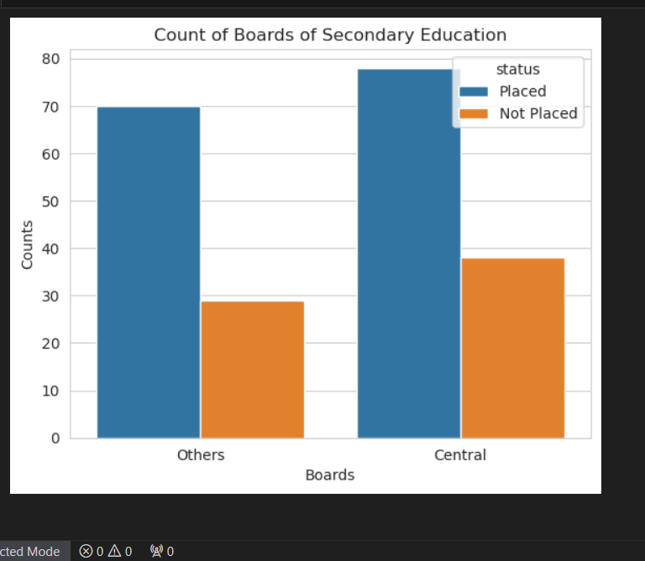

**FIG :Placement distribution based on Higher Secondary**

**Education percentage distinguished by Gender**

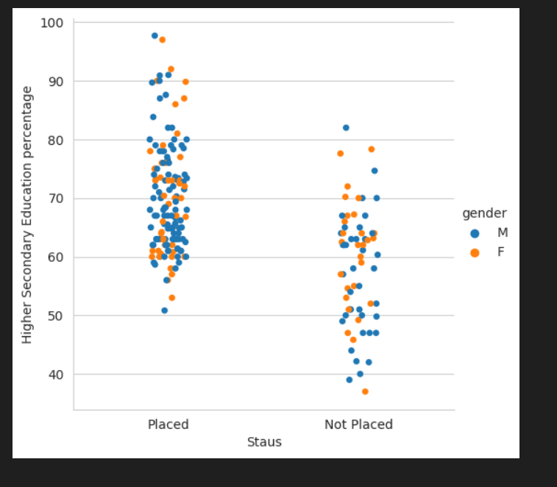

**FIG :Placement by Higher Education Boards**

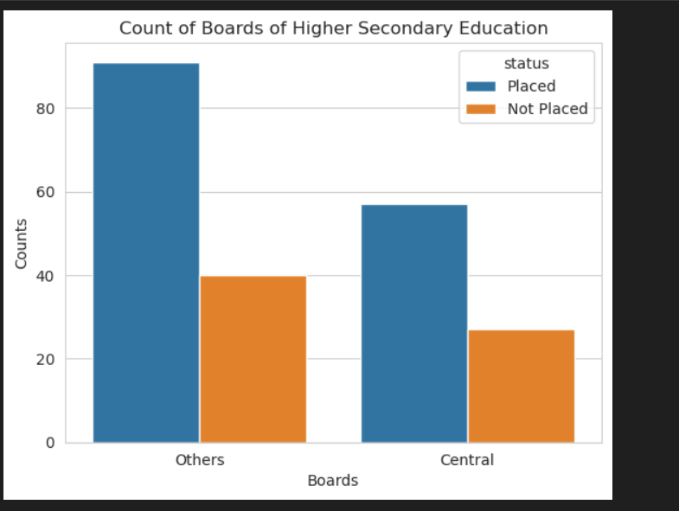

**FIG : Placement by Gender**

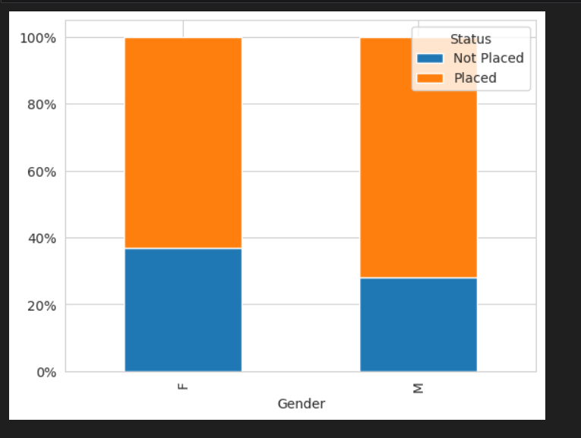

**FIG : Placement by Work Experience**

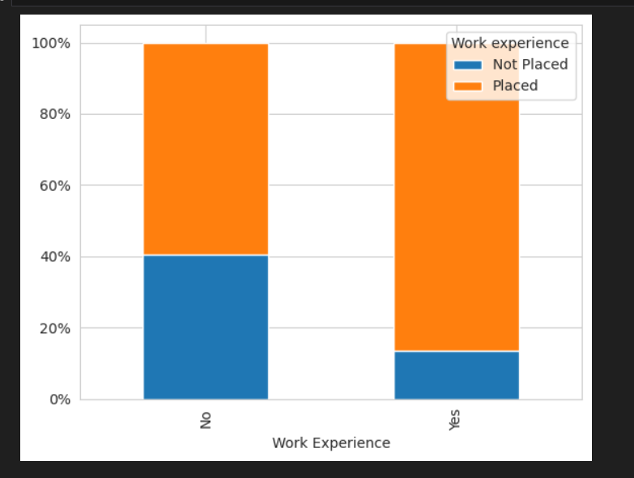

**FIG : Placement by Specialization**

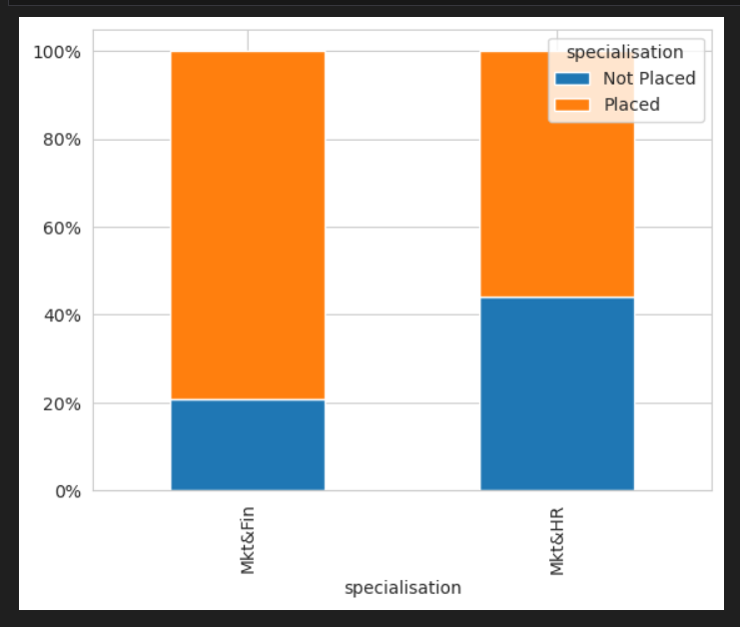

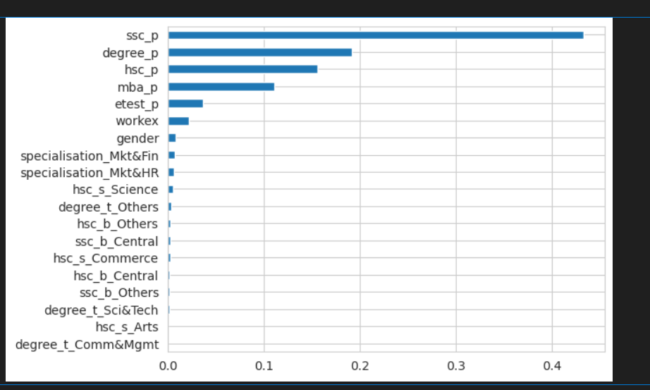

**FIG : Result Summary**

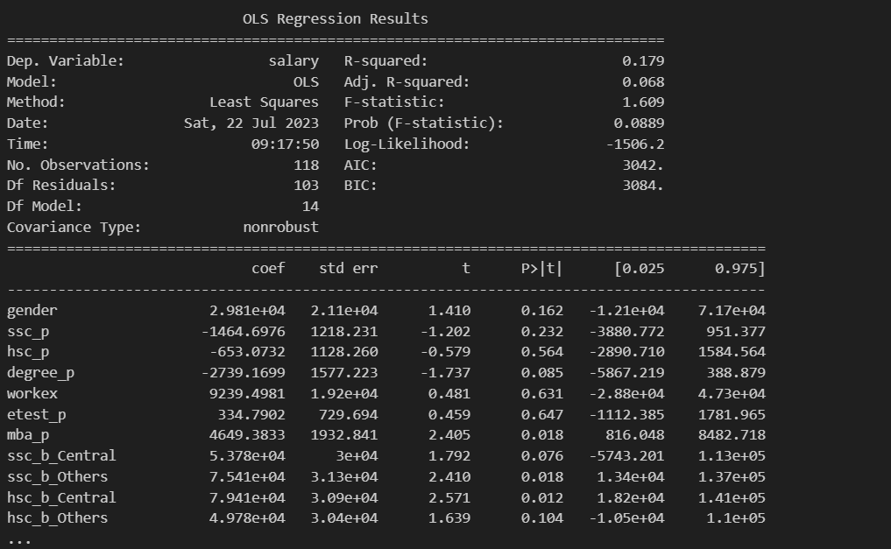

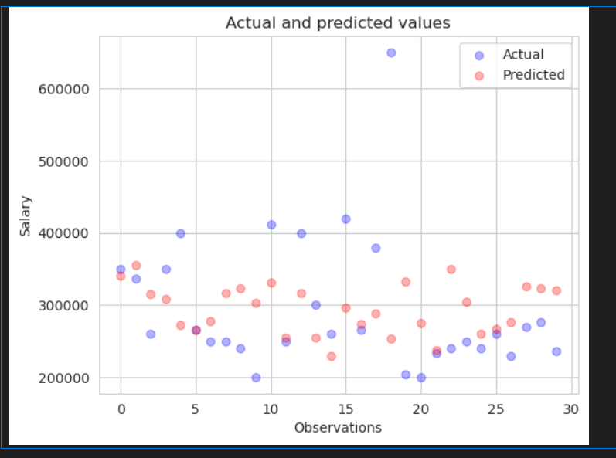

**CHAPTER 10**

**ADVANTAGES AND DISADVANTAGES**

**Advantages:**

1. **Data-Driven Insights**: Analytical tools can provide data-driven insights into the performance of ad placements. This data helps advertisers and marketers make informed decisions on where and how to allocate their advertising budgets.
2. **ROI Measurement**: Ad placement analytical tools can help calculate the return on investment (ROI) for different ad placements. Advertisers can identify which placements are most cost-effective and generate the highest returns.
3. **Target Audience Assessment**: These tools often include audience analytics, allowing advertisers to understand the demographics and behaviors of the audience reached by specific ad placements. This information can help refine targeting strategies.
4. **Performance Tracking**: Analytical tools can track key performance metrics such as click-through rates (CTR), conversion rates, and engagement levels for different ad placements. This information is crucial for optimizing ad campaigns.
5. **A/B Testing**: Advertisers can use these tools to conduct A/B tests on different ad placements, ad creatives, or targeting parameters to determine which variations perform best.
6. **Budget Allocation**: By analyzing the performance data, advertisers can allocate their advertising budget more efficiently. They can shift budget towards placements that deliver the best results.

**Disadvantages:**

1. **Complexity and Learning Curve**: Some placement analytical tools can be complex and require a learning curve to use effectively. Users may need to invest time in training and becoming proficient with the tool.
2. **Cost:** Many advanced placement analytical tools come with a price, which can be a significant disadvantage for small businesses or individuals with limited budgets.
3. **Data Quality:** The accuracy and reliability of the data used by these tools can be a concern. Data may be incomplete or include inaccuracies, leading to misleading insights.
4. **Data Privacy and Compliance**: Handling and analyzing user data for ad placement may raise privacy and compliance issues, particularly in regions with strict data protection regulations like GDPR. Adhering to these rules can be challenging.
5. **Over-Reliance on Data**: Relying solely on analytical tools can lead to a loss of intuition and creativity in advertising. Human judgment and creativity are essential in the field of marketing.

**CHAPTER 11**

**CONCLUSIONS**

Various classification and clustering techniques are inspected to evaluate the performance of students in the recruitment procedure. Using the comparative study amongst these techniques ID3 with accuracy 95.33%, KNN with 97.33%, C4.5 with 88.89%, Naïve bayes with 86.15 %, Multilayer perception having 87.395% accuracy is suggested to be the best one. If placement cell conduct workshop in advance for pre-final year to train them according to the result of these techniques, students will be able to identify their scope of improvement and will be able to refine themselves accordingly.

**CHAPTER 12**

**FUTURE SCOPE**

It would of great help if we revise and update our curriculum and other extra activities for each semester in accordance with the public, private and government sector requirement. We can also predict which company picks which category of students. Make a list of skill a particular company looking for, then on the basis of that we can train our student. These traits will make prediction process more accurate.

**CHAPTER 13**

**APPENDIX**

**SOURCE CODE:**

import pandas as pd

import numpy as np

from sklearn.linear_model import LogisticRegression

from sklearn.ensemble import RandomForestRegressor

from sklearn.ensemble import RandomForestClassifier

from sklearn.model_selection import train_test_split

from sklearn import preprocessing

from sklearn.metrics import confusion_matrix

from sklearn.metrics import roc_auc_score

from sklearn.metrics import classification_report

import statsmodels.api as sm

import matplotlib.pyplot as plt

import matplotlib.ticker as mtick

import seaborn as sns

sns.set_style('whitegrid')

df = pd.read_csv('/kaggle/input/factors-affecting-campus-placement/Placement_Data_Full_Class.csv')

df.head(10)

df.drop('sl_no', inplace = True, axis = 1)

df.info()

df.isnull().sum()

df.describe()

sns.pairplot(data = df, hue = 'status')

sns.countplot(x = df['gender'])

plt.title('Demographics for Placement')

plt.xlabel('Gender')

plt.show()

sns.countplot(x = df['status'])

plt.xlabel('Status')

plt.show()

sns.catplot(x = 'status', y = 'ssc_p', hue = 'gender', data = df)

plt.xlabel('Staus')

plt.ylabel('Secondary Education percentage')

plt.show()

sns.boxplot(x = 'salary', y = 'ssc_b', data = df)

plt.title('Boxplot of salary by Board of Secondary Education')

plt.ylabel('Boards')

plt.xlabel('Salary')

plt.show()

sns.countplot(x = 'ssc_b', hue='status', data = df)

plt.title('Count of Boards of Secondary Education')

plt.xlabel('Boards')

plt.ylabel('Counts')

plt.show()

df.groupby('ssc_b')['status'].value_counts(normalize=False)

sns.catplot(x = 'status', y = 'hsc_p', hue = 'gender', data = df)

plt.xlabel('Staus')

plt.ylabel('Higher Secondary Education percentage')

plt.show()

sns.boxplot(x = 'salary', y = 'hsc_b', data = df)

plt.title('Boxplot of Salary by Higher Secondary Boards')

plt.xlabel('Salary')

plt.ylabel('Higher Secondary Boards')

plt.show()

sns.countplot(x = 'hsc_b', hue='status', data = df)

plt.title('Count of Boards of Higher Secondary Education')

plt.xlabel('Boards')

plt.ylabel('Counts')

plt.show()

df.groupby('hsc_b')['status'].value_counts(normalize=False)

sns.boxplot(x = 'salary', y = 'gender', data = df)

plt.title('Boxplot of Salary by Gender')

plt.show()

df.groupby(["gender","status"]).size().groupby(level=0, group_keys = False).apply( lambda x: 100 * x / x.sum()).unstack().plot(kind='bar',stacked=True)

plt.gca().yaxis.set_major_formatter(mtick.PercentFormatter())

plt.legend(loc = 'upper right',title = 'Status')

plt.xlabel('Gender')

plt.show()

df.groupby(["workex","status"]).size().groupby(level=0, group_keys=False).apply( lambda x: 100 * x / x.sum()).unstack().plot(kind='bar',stacked=True)

plt.gca().yaxis.set_major_formatter(mtick.PercentFormatter())

plt.legend(loc = 'upper right',title = 'Work experience')

plt.xlabel('Work Experience')

plt.show()

ax = sns.countplot(x = 'workex', hue = df.gender, data = df)

totals = []

for i in ax.patches:

    totals.append(i.get_height())

total = sum(totals)

for i in ax.patches:

    ax.text(i.get_x()--.1, i.get_height()+.5, \

            str(round(i.get_height(), 2)), fontsize=15,

                color='red')

plt.show()

df.groupby(["specialisation","status"]).size().groupby(level=0, group_keys = False).apply( lambda x: 100 * x / x.sum()).unstack().plot(kind='bar',stacked=True)

plt.gca().yaxis.set_major_formatter(mtick.PercentFormatter())

plt.legend(loc = 'upper right',title = 'specialisation')

plt.show()

sns.regplot(x = 'ssc_p', y = 'salary', data = df)

plt.xlabel('Secondary Education Percentage')

plt.ylabel('Salary')

plt.show()

sns.regplot(x = 'hsc_p', y = 'salary', data = df)

plt.xlabel('Higher Secondary Education Percentage')

plt.ylabel('Salary')

plt.show()

sns.regplot(x = 'degree_p', y = 'salary', data = df)

plt.xlabel('Degree Percentage')

plt.ylabel('Salary')

plt.show()

sns.regplot(x = 'mba_p', y = 'salary', data = df)

plt.xlabel('MBA Percentage')

plt.ylabel('Salary')

plt.show()

df.loc[df['gender'] == 'M', 'gender'] = 1.0

df.loc[df['gender'] == 'F', 'gender'] = 0.0

df.loc[df['status'] == 'Placed', 'status'] = 1

df.loc[df['status'] == 'Not Placed', 'status'] = 0

df.loc[df['workex'] == 'Yes', 'workex'] = 1.0

df.loc[df['workex'] == 'No', 'workex'] = 0.0

categorical_var = ['ssc_b','hsc_b','hsc_s','degree_t','specialisation']

for variable in categorical_var:

    df[variable].fillna('Missing', inplace = True)

    dummies = pd.get_dummies(df[variable], prefix=variable)

    df = pd.concat([df,dummies],axis=1)

    df.drop([variable],axis=1,inplace=True)

df.head()

recruit_placed = df[df['status'] == 1].drop('status',axis = 1)

recruit_placed.head()

x = df.drop(['status','salary'], axis=1)

y = df['status'].astype(float)

train_x, test_x, train_y, test_y = train_test_split(x,y , test_size=0.3, random_state=42)

print(train_x.shape)

print(train_y.shape)

rf_regressor = RandomForestRegressor(100, oob_score=True, n_jobs=-1, random_state=42)

rf_regressor.fit(train_x,train_y)

print('Score: ', rf_regressor.score(train_x,train_y))

feature_importance = pd.Series(rf_regressor.feature_importances_,index=x.columns)

feature_importance = feature_importance.sort_values()

feature_importance.plot(kind='barh')

results = []

n_estimator_options = [30,50,100,200,500,1000,2000]

for trees in n_estimator_options:

    model = RandomForestRegressor(trees,oob_score=True,n_jobs=-1,random_state=42)

    model.fit(x,y)

    print(trees," trees")

    score = model.score(train_x,train_y)

    print(score)

    results.append(score)

    print("")

pd.Series(results,n_estimator_options).plot()

results = []

max_features_options = ['auto',None,'sqrt','log2',0.9,0.2]

for max_features in max_features_options:

    model = RandomForestRegressor(n_estimators=200,oob_score=True,n_jobs=-1, random_state=42,max_features=max_features)

    model.fit(x,y)

    print(max_features," option")

    score = model.score(train_x,train_y)

    print(score)

    results.append(score)

    print("")

pd.Series(results,max_features_options).plot(kind='barh')

results = []

min_sample_leaf_option = [1,2,3,4,5,6,7,8,9,10]

for min_sample_leaf in min_sample_leaf_option:

    model = RandomForestRegressor(n_estimators=200,oob_score=True,n_jobs=-1,

                                  random_state=42,max_features='sqrt',

                                  min_samples_leaf=min_sample_leaf)

    model.fit(x,y)

    print(min_sample_leaf," min samples")

    score = model.score(train_x,train_y)

    print(score)

    results.append(score)

    print("")

pd.Series(results,min_sample_leaf_option).plot()

rf_regressor = RandomForestRegressor(200, oob_score=True,max_features='sqrt', n_jobs=-1, random_state=42, min_samples_leaf=1)

rf_regressor.fit(x,y)

print('Score: ', rf_regressor.score(train_x,train_y))

pred_y = rf_regressor.predict(test_x)

print(test_y[:10])

print(pred_y[:10])

rf_classifier = RandomForestClassifier(200, oob_score=True,

                                     n_jobs=-1, random_state=42)

rf_classifier.fit(train_x, train_y)

pred_y = rf_classifier.predict(test_x)

rf_classifier.score(test_x, test_y)

mat = confusion_matrix(test_y,pred_y)

sns.heatmap(mat, square=True, annot=True, cbar=False)

plt.xlabel('predicted value')

plt.ylabel('true value')

plt.show()

print(classification_report(test_y, pred_y))

lr_model = LogisticRegression()

lr_model.fit(train_x,train_y)

lr_model.score(test_x, test_y)

pred_y = lr_model.predict(test_x)

mat = confusion_matrix(test_y,pred_y)

sns.heatmap(mat, square=True, annot=True, cbar=False)

plt.xlabel('predicted value')

plt.ylabel('true value')

print(classification_report(test_y, pred_y))

lr_coef = pd.DataFrame({"Coefficients":lr_model.coef_[0]},index = x.columns.tolist())

lr_coef = lr_coef.sort_values(by = 'Coefficients')

lr_coef

lr_coef.plot(kind='barh')

recruit_placed.head()

sns.pairplot(recruit_placed[['ssc_p','hsc_p','degree_p','etest_p','mba_p','salary']])

recruit_placed[['ssc_p','hsc_p','degree_p','etest_p','mba_p','salary']].corr()

var = ['ssc_p','hsc_p','degree_p','etest_p','mba_p','gender','workex']

x = recruit_placed.loc[:,var]

x = recruit_placed.loc[:,recruit_placed.columns != 'salary']

y = recruit_placed.loc[:,recruit_placed.columns == 'salary']

x.head()

train_x, test_x, train_y, test_y = train_test_split(x,y , test_size=0.2, random_state=42)

print(train_x.shape)

print(test_x.shape)

linear_model = sm.OLS(train_y,train_x.astype(float))

results = linear_model.fit()

results.params

print(results.summary())

pred_y = results.predict(test_x)

print(pred_y[:10])

print(test_y[:10])

col = ['actual','prediction']

prediction = pd.concat([test_y,pred_y],axis=1)

prediction.columns = col

prediction

_, ax = plt.subplots()

ax.scatter(x = range(0, test_y.size), y=test_y, c = 'blue', label = 'Actual', alpha = 0.3)

ax.scatter(x = range(0, pred_y.size), y=pred_y, c = 'red', label = 'Predicted', alpha = 0.3)

plt.title('Actual and predicted values')

plt.xlabel('Observations')

plt.ylabel('Salary')

plt.legend()

plt.show()